Oracle Supply Chain Management (SCM) Implementation Guide for a Pharmaceutical Distribution Company

# **Abstract**

This document provides a comprehensive guide for the implementation of Oracle Supply Chain Management (SCM) solutions within a pharmaceutical distribution company, AB Pharmacies. It outlines the project objectives, scope, and expected outcomes, focusing on improving operational efficiency, regulatory compliance, and financial accuracy. The guide details the system configuration steps across key SCM modules, including Inventory Management, Purchasing, Order Management, and Financials, tailored specifically to the needs of the pharmaceutical industry.  
Through structured phases of planning, setup, training, and deployment, the implementation aims to modernize the supply chain processes, enhance inventory visibility, automate procurement workflows, and ensure real-time tracking of product expirations. The document serves as both a strategic roadmap and a practical manual for achieving a seamless transition to Oracle E-Business Suite SCM applications, enabling AB Pharmacies to better meet market demands while maintaining high standards of compliance and service excellence.

# **Acknowledgment**

I would like to extend my deepest gratitude to all those who contributed to the successful implementation of this Oracle SCM project.

Special thanks to the **Digital Egypt Pioneers Initiative (DEPI)** for providing the comprehensive training program that built the foundation for this implementation. Your support and vision for digital transformation have been invaluable.

I would also like to express my sincere appreciation to **Engineer Ahmed Bakar**, our dedicated instructor, whose expert guidance, insightful explanations, and continuous encouragement greatly enhanced our learning and practical application.

I am also thankful to the management and operational teams at AB Pharmacies for their cooperation, active participation, and trust throughout this project journey.

Contents

Abstract 2

Acknowledgment 3

1. Project Overview 7

Objective: 7

Scope of Work: 7

Expected Outcomes: 7

2. Project Planning & Requirements Gathering 7

2.1 Define Business Objectives 7

2.2 Identify Key SCM Modules 8

2.3 Implementation Roadmap 8

3. Scope of the Project 8

3.1 Inventory Management: 8

3.2 Purchasing and Order Management: 8

3.3 Warehouse Management: 9

3.4 Integration: 9

3.5 Reporting and Analytics: 9

3.6 Training and Change Management: 9

4. System Configuration & Setup – Step-by-Step Walkthrough 10

4.1 Define Chart of Accounts (COA) 10

4.2 Define Locations 12

4.3 Define Legal Entity, Operating Units, Inventory Orgs, and Sub inventories 12

4.5 Assign Costing Methods and Calendar 28

4.6 Configure Inter-Organization Shipping Networks 30

**4.7 Create Custom Responsibilities and Assign to Users** 32

**4.8 Create Master Organization and Inventory Organizations** 34

Purchasing Module Configuration 36

Over view 37

Step-by-Step Configuration 37

1. Define Financials Options for AB Pharmacies OU 37

2. Step-by-Step: Buyer Setup in Oracle Purchasing 41

3. Creating an Approval Group in Oracle Purchasing 47

Step 1: Open the Approval Groups Form 47

Step 2: Create a New Approval Group 47

Step 3: Define Approval Limits 48

Step 4: Assign the Approval Group to Position or Job 48

✅ Result: 49

Configure Min-Max Planning with Internal Replenishment 49

Configure Min-Max Planning at Subinventory Level (Retail) 52

Conclusion 55

References 56

## Table of Figures

Figure 1 COA Key FlexField 11

Figure 2 Vision Operations COA 12

Figure 3 Define Segments 13

Figure 4 Define Location Screen 13

Figure 5 Define Legal Entity 14

Figure 6 Create operating unit 15

Figure 7 Set the Operating Unit Classification 15

Figure 8 Request Submission for Replicate Seed Data 16

Figure 9 Assign the Operating Unit to a Responsibility 17

Figure 10 Create Stock Locator Key Flexfield 17

Figure 11 Segment Definition for Stock Locator 18

Figure 12 Find Organizations Form 19

Figure 13 Locator Control Option in Inventory Parameters 20

Figure 14 Create Inventory Organization: AB WH_Org 21

Figure 15 Define inventory parameter 21

Figure 16 Define Costing Method 22

Figure 17 Create a Subinventory Cairo WH 23

Figure 18 List of Stock Locator of main wearhous 24

Figure 19 Create Subinventory of Upper WH 25

Figure 20 List of Subinventory of WH_org 26

Figure 21 Create Inventory Organization: AB Retail_Org 27

Figure 22 Create Subinventories for AB Retail_Org 28

Figure 23 Stock Locators For Ratial Subinventory 28

Figure 24 Verify AB Retail_Org and Subinventories 29

Figure 25 Organization Parameters Screen 30

Figure 26 assign Cost center for AB_WH_Org 31

Figure 27 Shipping Network Eatery Screen 32

Figure 28 Responsibility Creation Screen 33

Figure 29 Profile Options Form 34

Figure 30 User Form with Assigned Responsibilities 35

Figure 31 Master Organization Setup Screen 36

Figure 32 Operating Unit Query Form 38

Figure 33 Setup Accounting Informations 39

Figure 34 Setup Supplier – Purchasing 40

Figure 35 Setup HR Tab and Other Options 41

Figure 36 Purchasing Options Setup Screen 42

Figure 37 Define Buyer 43

Figure 38 Grant Buyer Access 43

Figure 39 setup Positions Hierarchy 44

Figure 40 Link Buyer to user Account 44

Figure 41 Create Requisition 45

Figure 42 Define Suppliers and Supplier Sites 46

Figure 43 Supplier Setup Screen 46

Figure 44 Setup Apporvoal Method 47

Figure 45 Purchase Order Document Types Setup Screen 48

Figure 46 Create approval group 49

Figure 47 Assign the Approval Group to Position 50

Figure 48 Enable Min-Max Planning for the Item 51

Figure 49 Set Item Attributes in Receiving Org (Retail Org) 52

Figure 50 Set Min-Max Planning Parameters at Item-Subinventory Level 54

Figure 51 Min-Max Planning Report 55

## 1. Project Overview

### Objective:

This project aims to implement an integrated Supply Chain Management (SCM) solution using Oracle ERP for AB Pharmacies, a leading provider of pharmaceutical products and services. Currently, AB Pharmacies faces challenges in supply chain management, including:

* Inventory stock outs and overstocking
* Inefficient order processing
* Lack of real-time visibility
* Difficulty tracking expiry dates
* Ineffective costing methods impacting financial accuracy

These issues affect operational efficiency, profitability, and customer satisfaction. The proposed solution will streamline and optimize the entire supply chain from procurement to delivery using Oracle's comprehensive suite of applications.

### Scope of Work:

* Enhance supply chain visibility and agility
* Improve inventory management and reduce stock outs
* Streamline procurement and order fulfillment processes
* Optimize distribution and logistics
* Increase operational efficiency and reduce costs
* Enhance customer satisfaction
* Track and manage product expiry dates
* Implement a standardized and efficient costing method for financial accuracy

### Expected Outcomes:

* Configured supply chain modules
* Business sustainability and continuity
* Operational Efficiency: Faster decision-making and reduced downtime through automation and centralized data
* Cost Savings: Optimized resource allocation and reduced manual intervention
* Customer Satisfaction: Improved transparency and service levels
* Scalability: ERP will support future growth and evolving market demands

## 2. Project Planning & Requirements Gathering

### 2.1 Define Business Objectives

* Optimize inventory management
* Improve order fulfillment efficiency
* Ensure regulatory compliance (GMP, FDA, EMA)
* Enhance supplier and customer management

### 2.2 Identify Key SCM Modules

* **Oracle Inventory Management** – Stock tracking, lot control, and expiration management
* **Oracle Purchasing** – Supplier procurement and purchase order (PO) management
* **Oracle Order Management** – Sales order processing and customer fulfillment
* **Oracle Financials Integration** – Accounting, AP, and AR integration

### 2.3 Implementation Roadmap

#### Phase 1: Requirements Gathering & System Design

* 1. Conduct stakeholder meetings
  2. Define business requirements and workflows
  3. Identify integration points with existing systems

#### Phase 2: System Configuration & Setup

* 1. Configure organization structure, COA, and modules
  2. Define approval workflows and security settings

#### Phase 3: Data Migration & Validation

* 1. Cleanse and migrate master data (items, suppliers, customers)
  2. Validate data accuracy and completeness

#### Phase 4: Testing & User Training

* 1. Conduct User Acceptance Testing (UAT)
  2. Train key users on system functionalities

#### Phase 5: Go-Live & Post-Implementation Support

* 1. Deploy system into production
  2. Monitor performance and resolve post-go-live issues

## 3. Scope of the Project

### 3.1 Inventory Management:

Implement Oracle Inventory Management to:

* Optimize stock levels
* Track inventory movements across pharmacies and warehouses
* Manage expiry dates
* Minimize stock outs and overstocking

### 3.2 Purchasing and Order Management:

Deploy Oracle Purchasing and Order Management to:

* Automate procurement
* Manage supplier relationships
* Streamline order placement and fulfillment
* Improve purchase price variance

### 3.3 Warehouse Management:

Depending on the complexity of AB Pharmacies' operations, Oracle Warehouse Management System (WMS) may be utilized to:

* Optimize warehouse layout
* Improve picking and packing efficiency
* Enhance inventory accuracy

### 3.4 Integration:

The Oracle SCM solution will be integrated with:

* Point of Sale (POS) system for real-time sales data
* Customer Relationship Management (CRM) system for customer demand insights

### 3.5 Reporting and Analytics:

Develop custom reports and dashboards using Oracle Business Intelligence (BI) for:

* Real-time visibility into supply chain metrics
* Data-driven decision-making

### 3.6 Training and Change Management:

* Provide comprehensive training to staff on the new Oracle system
* Effectively manage the change process to ensure smooth adoption

## 4. System Configuration & Setup – Step-by-Step Walkthrough

### 4.1 Define Chart of Accounts (COA)

The Chart of Accounts (COA) is the foundation of your financial structure in Oracle. It represents the accounting structure that supports financial reporting and control.

#### ****Step-by-Step Instructions:****

##### ****1. Navigate to Account Structure****

* Responsibility: **General Ledger Super User**
* Menu: **Setup > Financials > Flexfields > Key > Segments**
* Query: **Flexfield Title = Accounting Flexfield**

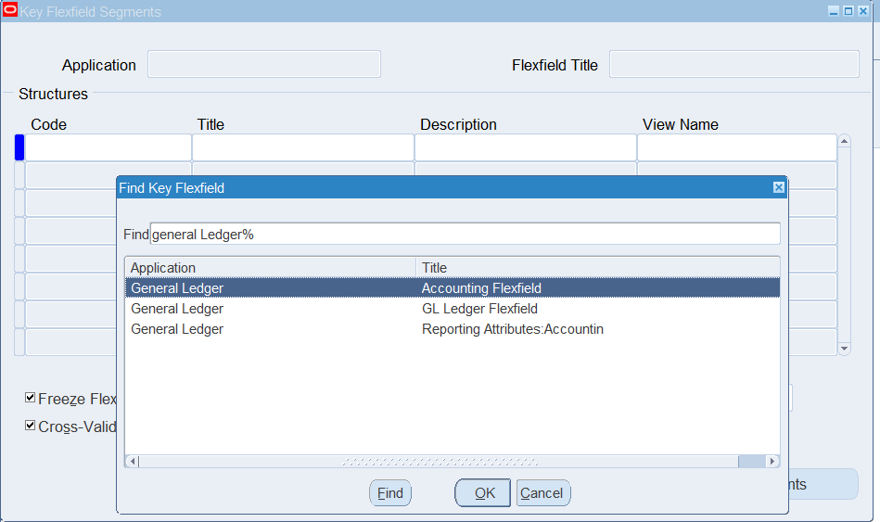

Figure 1 COA Key FlexField

##### ****2. Define Accounting Flexfield Structure****

* Click **Define**.
* Enter:
  + **Structure Code** (e.g., AB_COA) in this scenario we use Vision operations structure
  + **Title** (e.g., AB Chart of Accounts)
* Click **Segments** to define segment details.

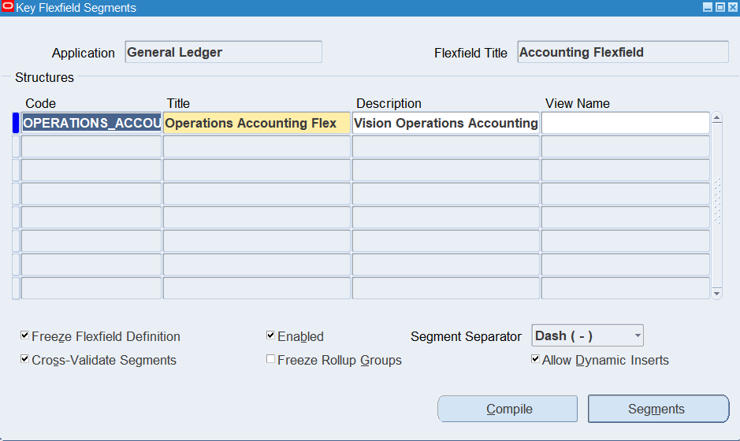

Figure 2 Vision Operations COA

##### ****3. Define Segments****

Each segment typically represents:

* **Company**
* **Department**
* **Account**
* **Sub Account**
* **Product**

For each segment:

* Enter:
  + **Name** (e.g., Company)
  + **Window Prompt**
  + **Column**
  + **Value Set** (Create or choose predefined value sets)
* Mark the required segments.

##### 

Figure 3 Define Segments

### 4.2 Define Locations

* Responsibility: **HRMS or Inventory**
* Menu: Work Structures > Location\
* **Create New Location:**
  + Enter Location Name (e.g., Cairo Main Warehouse)
  + Address Line, Country, Postal Code, City, and State
  + Optional: Assign to Inventory Organization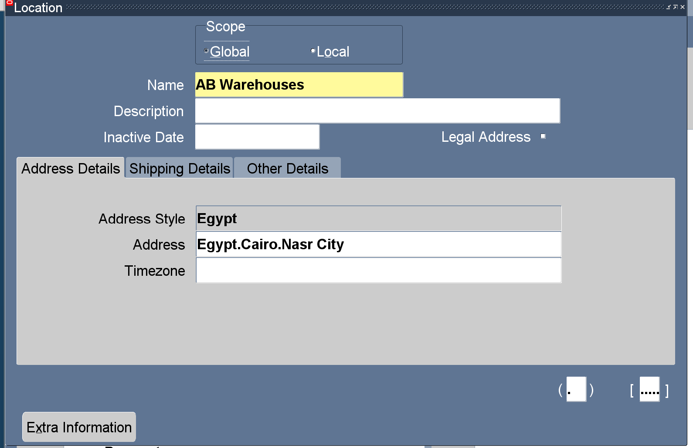

Figure 4 Define Location Screen

### 4.3 Define Legal Entity, Operating Units, Inventory Orgs, and Sub inventories

#### Step 1: Define Legal Entity

* Responsibility: **Accounting Setup Manager**
* Navigate to: **Setup > Financials > Accounting Setup Manager**
* Enter Legal Entity Name, Address, and Registration Number

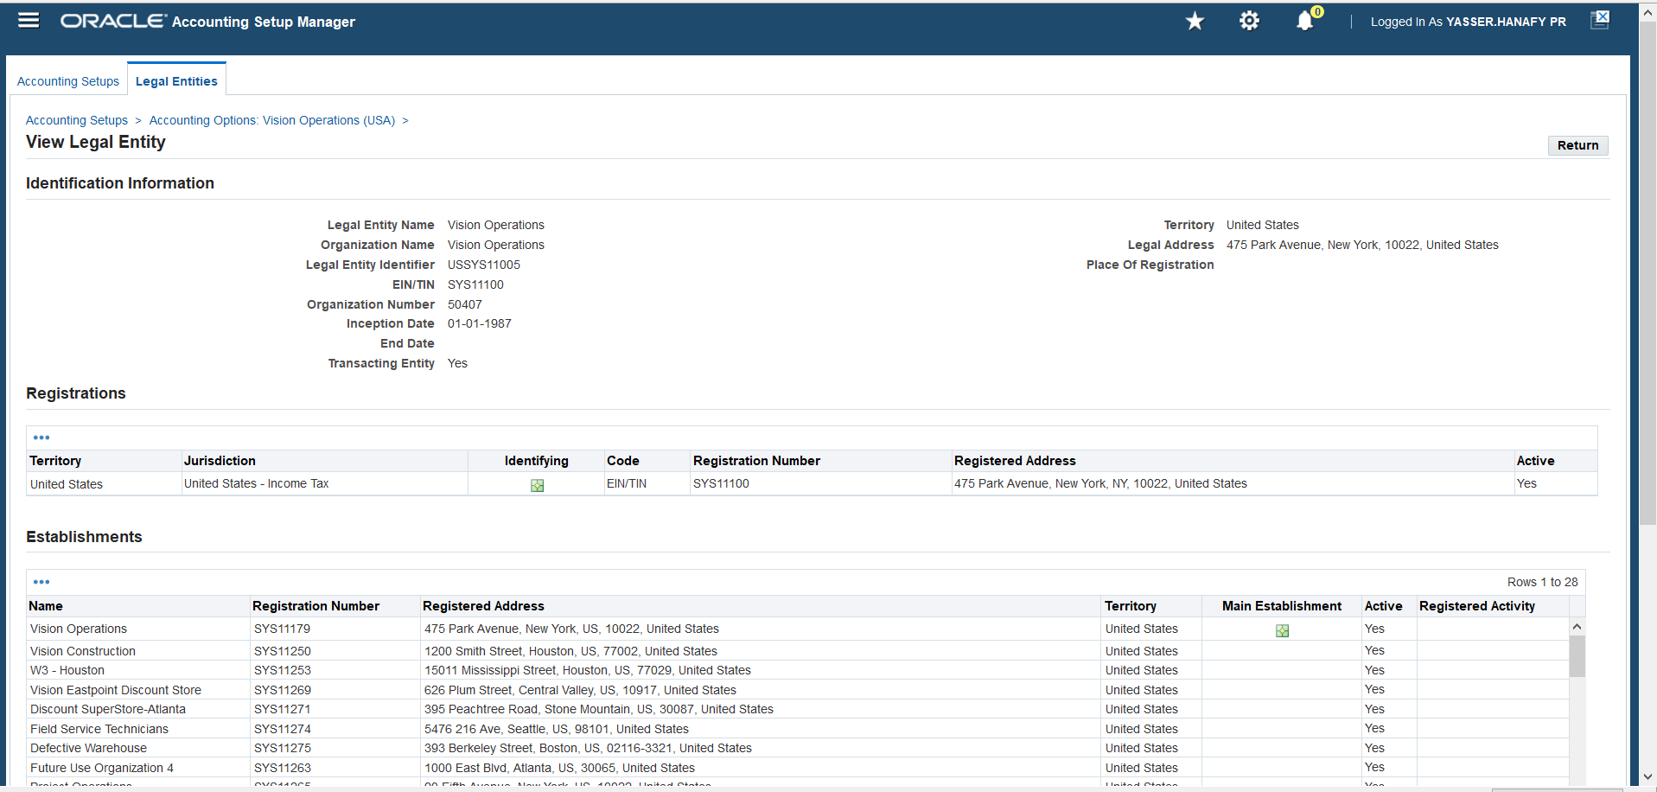

Figure 5 Define Legal Entity

#### Step 2: Create Operating Unit

* Automatically created during Legal Entity definition (attached to the Ledger)
* Assigned to an LE under Business Group

**Define Operating Units**

An Operating Unit (OU) is a key organizational structure in Oracle Applications. It represents a division or line of business within a company that performs transactions like sales orders, purchase orders, and receipts independently.

**Step-by-Step: Create an Operating Unit**

**Responsibility:** HRMS Manager  
**Navigation:** Work Structures > Organization > Description

**1. Create the Operating Unit Record**

1. Navigate to:  
   HRMS Manager > Work Structures > Organization > Description
2. In the **Name** field, enter:  
   AB Pharmcies
3. Select **Organization Type**:  
   Operating Unit
4. Save your entry.

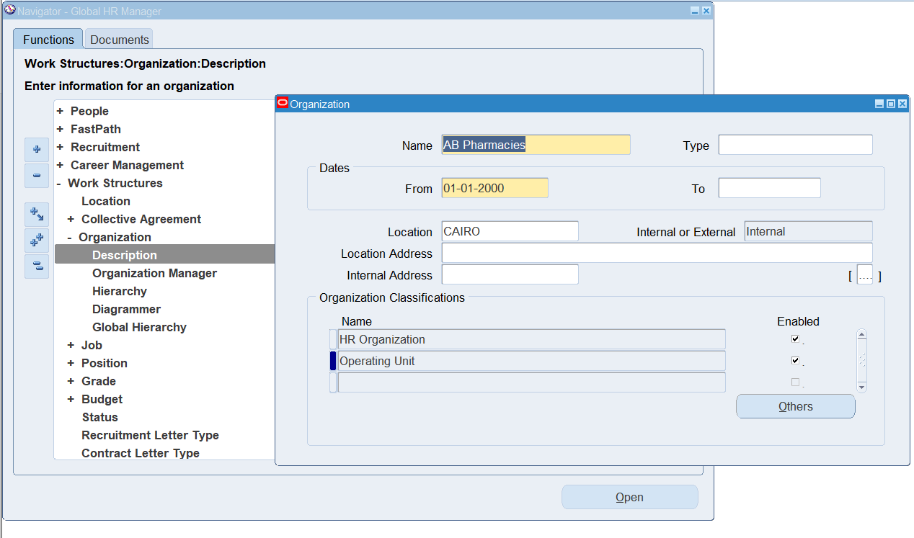

Figure 6 Create operating unit

**2. Set the Operating Unit Classification**

1. From the Description form, click **Others...**
2. In the **Organization Classifications** window:
   * Select **Operating Unit**
   * Click **Find**
3. Under Classification Details:
   * Assign the **Business Group**
   * Set the **Default Legal Context** (e.g., AB Pharm_LE)
4. Save your work.

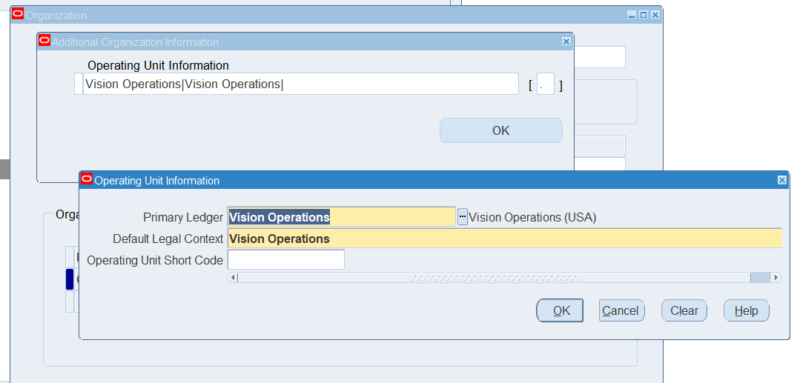

Figure 7 Set the Operating Unit Classification

**3. Run the**

**“Replicate Seed Data” Program**

This step is mandatory to populate relevant data into the new Operating Unit.

1. Go to:  
   System Administrator > Requests > Run
2. Choose **Single Request**
3. Enter:
   * **Program Name**: Replicate Seed Data
   * **Parameter**: Select AB Pharmacies
4. Submit the request.
5. Wait until the process completes successfully.

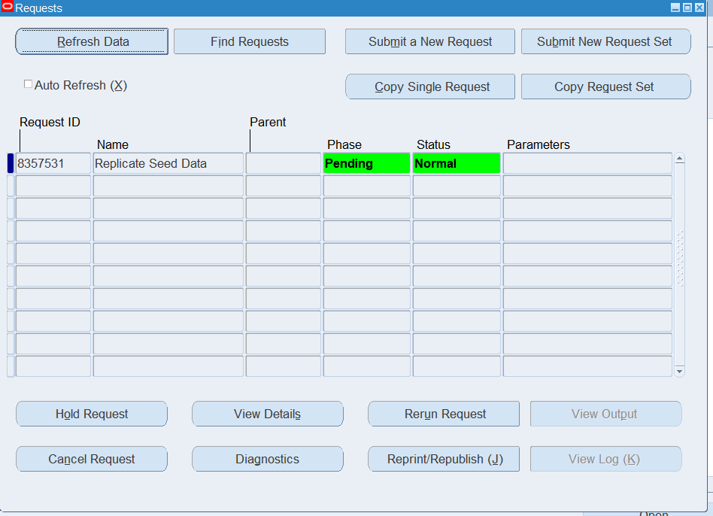

Figure 8 Request Submission for Replicate Seed Data

**4. Assign the Operating Unit to a Responsibility**

1. Navigate to:  
   System Administrator > Profile > System
2. Search for the Profile Option:  
   MO: Operating Unit
3. At the Responsibility level (e.g., “Purchasing Super User”), assign the value:  
   AB Pharmacies
4. Save.

📌 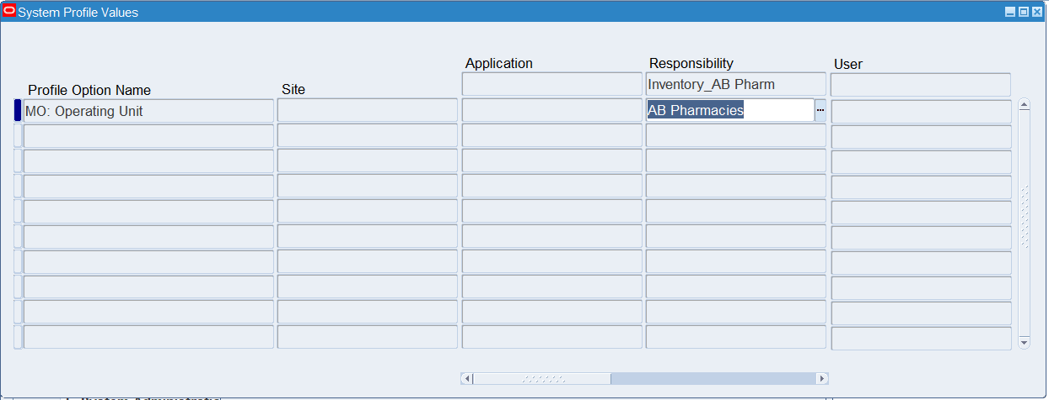

Figure 9 Assign the Operating Unit to a Responsibility

#### Step 3: ****Configure Inventory Key Flexfield for Stock Locator****

Oracle EBS requires the definition of a Key Flexfield for tracking locators within inventory. This is especially useful when managing large warehouses with detailed racking structures.

**Step-by-Step: Create Stock Locator Key Flexfield**

**Responsibility:** Inventory  
**Navigation:** Setup > Flexfields > Key > Segments

* **Navigate to Key Flexfield Setup**

1. Switch to the **Inventory Responsibility**
2. Go to: Setup > Flexfields > Key > Segments
3. Enter the following:
   * **Application:** Inventory
   * **Flexfield Title:** Stock Locator
4. Click **[Find]`

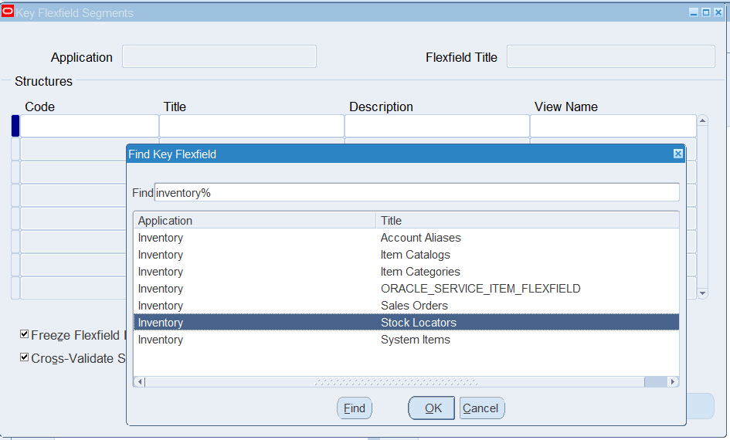

Figure 10 Create Stock Locator Key Flexfield

* **Define Segments**

1. Define the required segments (e.g., Row, Rack, Bin)
2. Assign:
   * Prompt names (e.g., Row)
   * Column names (e.g., SEGMENT1, SEGMENT2, SEGMENT3)
   * Value sets (if not available, define a new value set per segment)
3. Save your changes

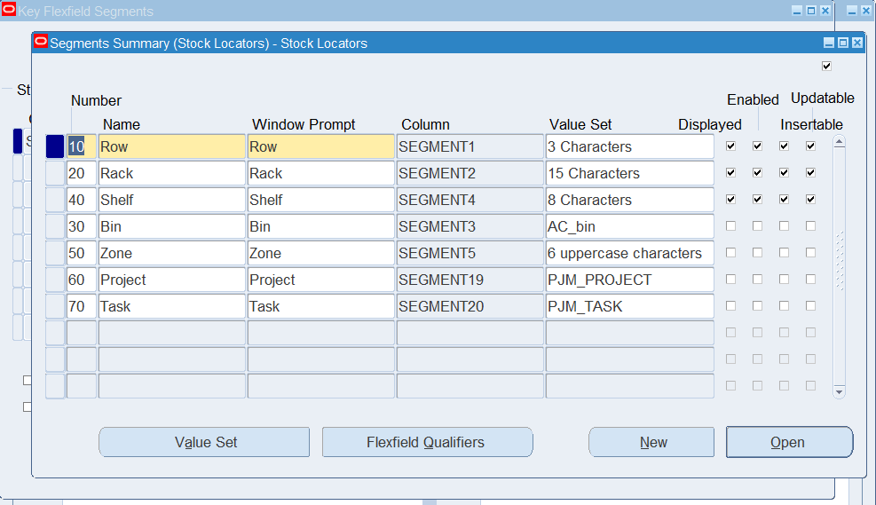

Figure 11 Segment Definition for Stock Locator

* **Compile the Flexfield**

1. Click **[Compile]** after setting up segments
2. Ensure the compilation status is successful
3. Exit the form

* **Enable Stock Locator Control at the Organization Level**

To make use of the Stock Locator Key Flexfield, you must enable locator control for each inventory organization where it’s applicable.

**Step-by-Step: Enable Locator Control**

**Responsibility:** Inventory  
**Navigation:** Setup > Organizations > Organizations

**Query the Inventory Organization**

1. From the **Inventory** responsibility, navigate to:

Setup > Organizations > Organizations

1. In the **Find Organizations** window:
   * Enter your inventory org name (e.g., AB WH_Org)
   * Click **[Find]**

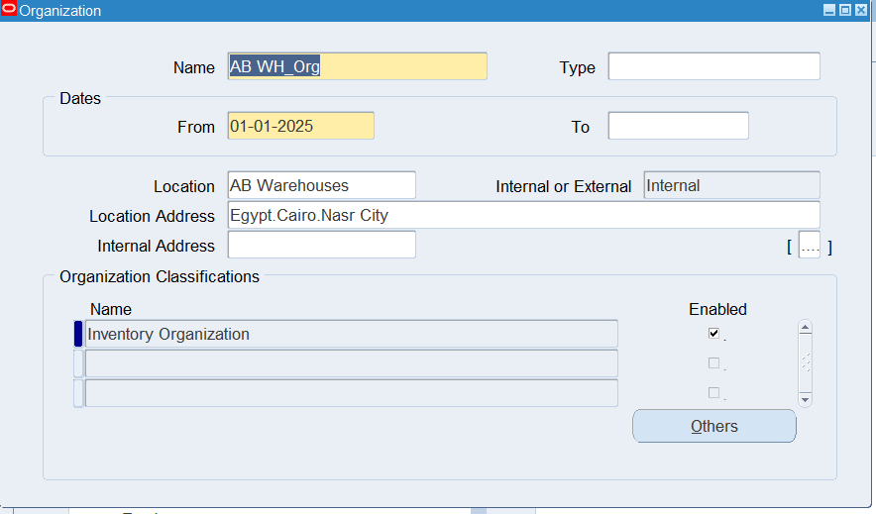

Figure 12 Find Organizations Form

**Enable Locator Control**

1. In the **Organization window**, click **[Inventory Information]**
2. In the **Inventory Parameters** window:
   * Locate **Locator Control**
   * Set value to:
     + Prespecified (if you want to control which locators are used)
     + Dynamic Entry (if users can enter locators on the fly)
     + Item Level (if locator control depends on item definition)
3. Optionally: define default locator structure
4. Save your changes

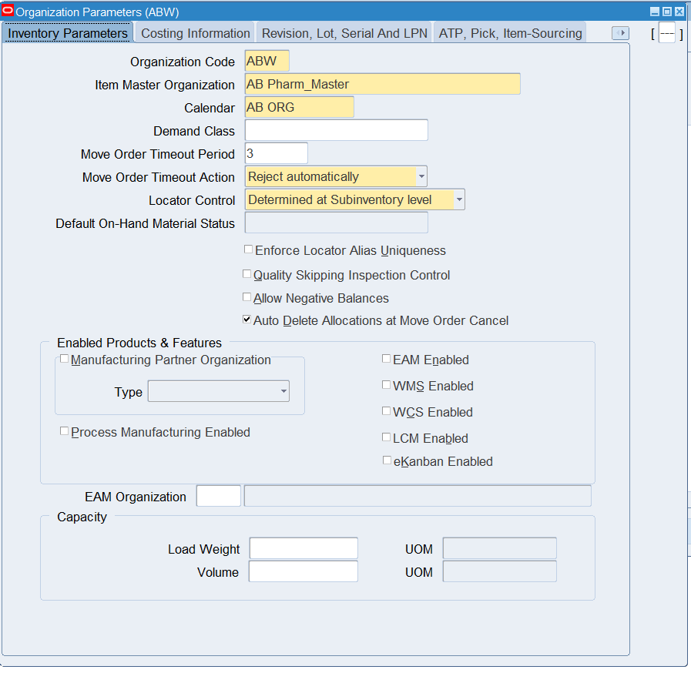

Figure 13 Locator Control Option in Inventory Parameters

#### Step 3: Define Inventory Organizations

1. **Create Inventory Organization: AB WH_Org**

**Responsibility:** Inventory Manager  
**Navigation:** Inventory > Setup > Organizations > Organizations

1. Navigate to:  
   Inventory > Setup > Organizations > Organizations
2. Click **Inventory Organizations** and then select **Create**.
3. In the **Organization Name** field, enter:  
   AB WH_Org
4. In the **Organization Code** field, enter:  
   ABW
5. In the **Location** field, select the location for this warehouse (AB Warehouses).
6. Set the **Organization Type** as:  
   Inventory Organization
7. For **Costing Method**, select the appropriate costing method for your organization (**Average Costing**).
8. Click **Save** to create the **AB WH_Org** Inventory Organization.

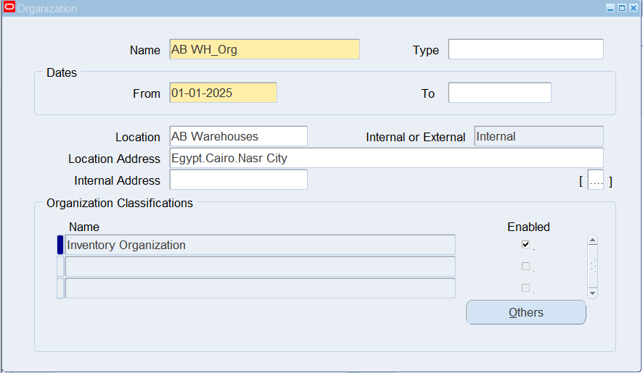

Figure 14 Create Inventory Organization: AB WH_Org

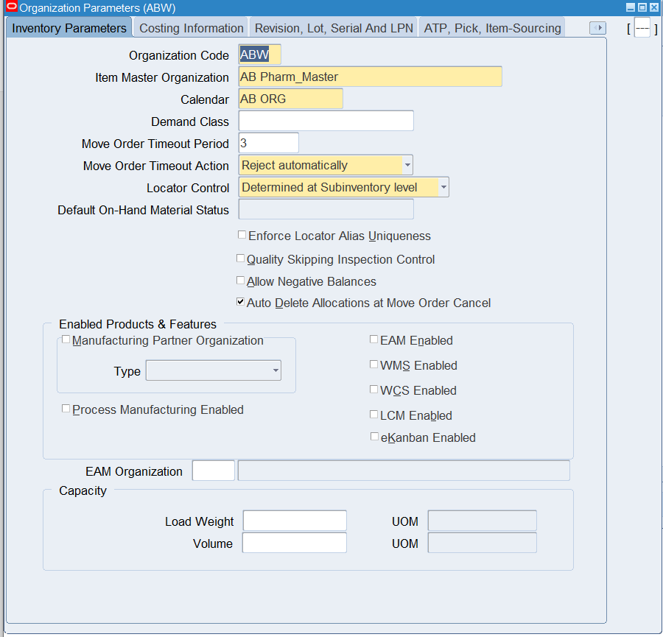

Figure 15 Define inventory parameter

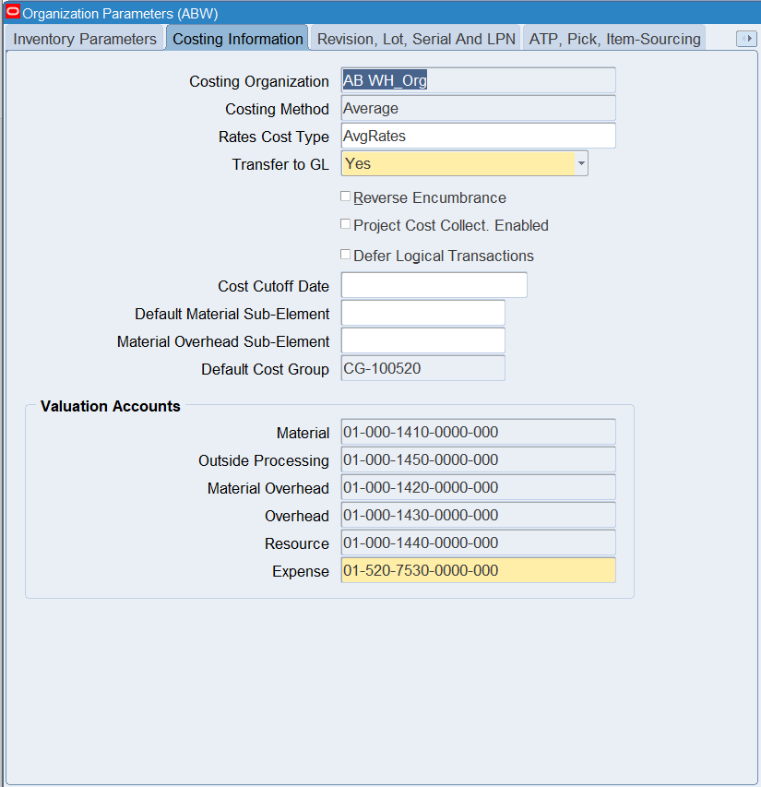

Figure 16 Define Costing Method

1. **Create Subinventories for AB WH_Org**

Now, we will create two subinventories for the **AB WH_Org**:

* **Cairo WH**
* **Upper WH**

**Responsibility:** Inventory Manager  
**Navigation:** Inventory > Setup > Organizations > Subinventories

##### ****Create Subinventory: Cairo WH****

1. Navigate to:  
   Inventory > Setup > Organizations > Subinventories
2. Click **Subinventories** and then select **Create**.
3. In the **Subinventory Code** field, enter:  
   CAIRO_WH
4. In the **Subinventory Name** field, enter:  
   Cairo WH
5. Select **Inventory Organization**:  
   AB WH_Org
6. Define locator by selecting locators Button

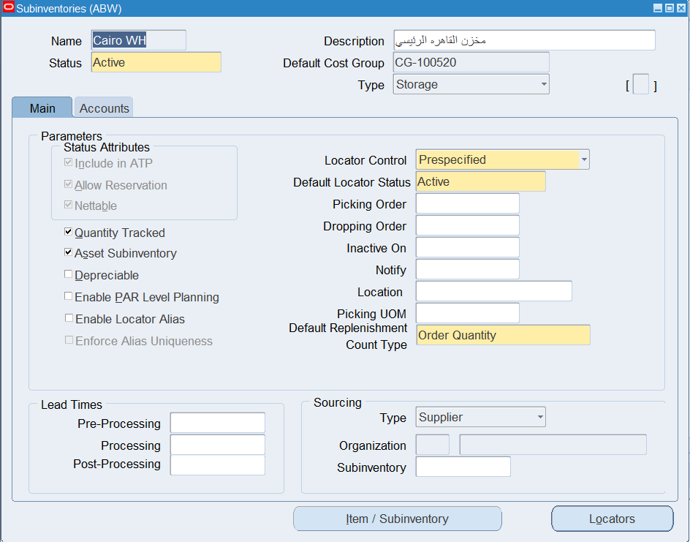

Figure 17 Create a Subinventory Cairo WH

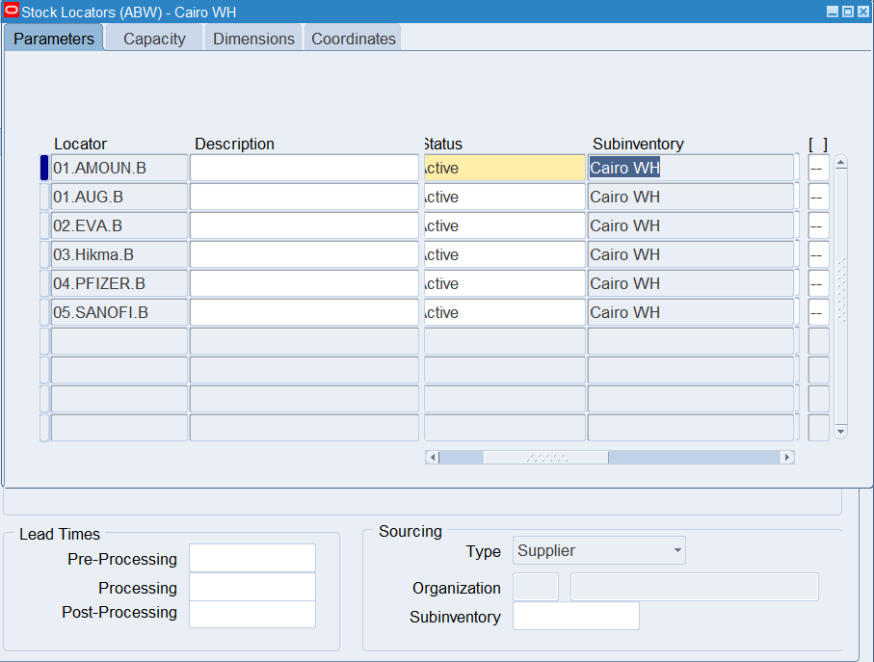

Figure 18 List of Stock Locator of main wearhous

1. Click **Save** to create the **Cairo WH** Subinventory

##### ****Create Subinventory: Upper WH****

1. Navigate to:  
   Inventory > Setup > Organizations > Subinventories
2. Click **Subinventories** and then select **Create**.
3. In the **Subinventory Code** field, enter:  
   UPPER_WH
4. In the **Subinventory Name** field, enter:  
   Upper WH
5. Select **Inventory Organization**:  
   AB WH_Org
6. Click **Save** to create the **Upper WH** Subinventory.

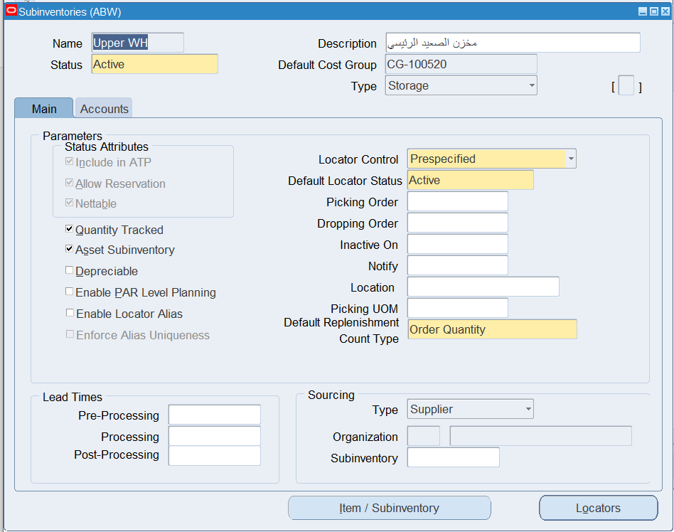

Figure 19 Create Subinventory of Upper WH

##### ****Verify AB WH_Org and Subinventories Setup****

To ensure that the Inventory Organization and Subinventories are set up correctly, you can verify by navigating to:

1. **Inventory Organization**:  
   Inventory > Setup > Organizations > Organizations  
   Ensure **AB WH_Org** is listed correctly.
2. **Subinventories**:  
   Inventory > Setup > Organizations > Subinventories  
   Ensure **Cairo WH** and **Upper WH** are listed correctly under **AB WH_Org**.

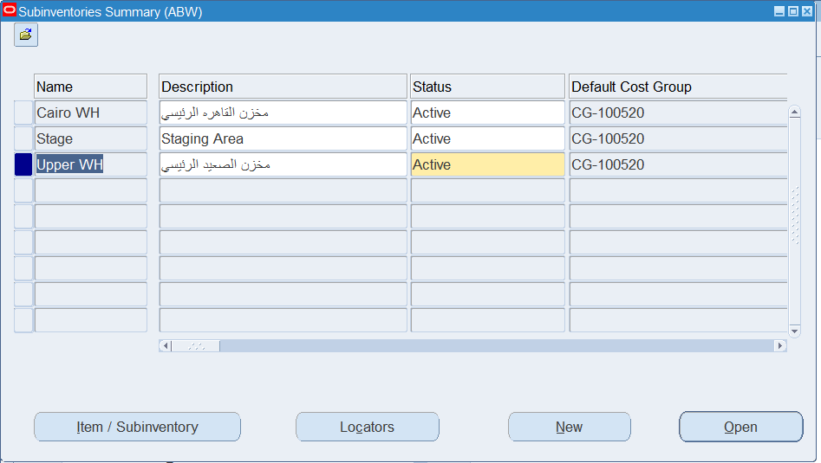

Figure 20 List of Subinventory of WH_org

1. **Create Inventory Organization: AB Retail_Org**

Now, let’s create the second inventory organization for **AB Retail_Org** which will contain five subinventories.

**Responsibility:** Inventory Manager  
**Navigation:** Inventory > Setup > Organizations > Organizations

1. Navigate to:  
   Inventory > Setup > Organizations > Organizations
2. Click **Inventory Organizations** and then select **Create**.
3. In the **Organization Name** field, enter:  
   AB Retail_Org
4. In the **Organization Code** field, enter:  
   ABRETAIL
5. In the **Location** field, select the location (e.g., Retail Location).
6. Set the **Organization Type** as:  
   Inventory Organization
7. For **Costing Method**, select the appropriate costing method (**Average Costing**).
8. Click **Save** to create the **AB Retail_Org** Inventory Organization.

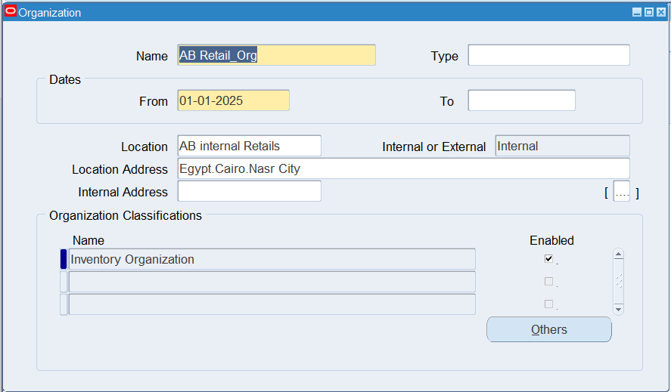

Figure 21 Create Inventory Organization: AB Retail_Org

1. **Create Subinventories for AB Retail_Org**

Next, we will create five Subinventories under the **AB Retail_Org**. Let's assume the Subinventories are for various retail locations or stores.

**Responsibility:** Inventory Manager  
**Navigation:** Inventory > Setup > Organizations > Subinventories

1. Navigate to:  
   Inventory > Setup > Organizations > Subinventories
2. Click **Subinventories** and then select **Create**.

##### ****Create Subinventory: A088 (فرع اسيوط - الجمهورية)****

1. In the **Subinventory Name** field, enter:  
   **A088** 1.
2. Define locator by selecting locators Button
3. Click **Save**.

##### 

Figure 22 Create Subinventories for AB Retail_Org

##### 

Figure 23 Stock Locators For Ratial Subinventory

##### ****Create Subinventory for other Subinventories****

**Repeat the above step for every Subinventories in the retail organization**

##### ****Verify AB Retail_Org and Subinventories Setup****

To ensure the Inventory Organization and Subinventories for **AB Retail_Org** are correctly set up, verify as follows:

1. **Inventory Organization**:  
   Inventory > Setup > Organizations > Organizations  
   Ensure **AB Retail_Org** is listed correctly.
2. **Subinventories**:  
   Inventory > Setup > Organizations > Subinventories  
   Ensure **Retail Store 1**, **Retail Store 2**, **Retail Store 3**, **Retail Store 4**, and **Retail Store 5** are listed correctly under **AB Retail_Org**.

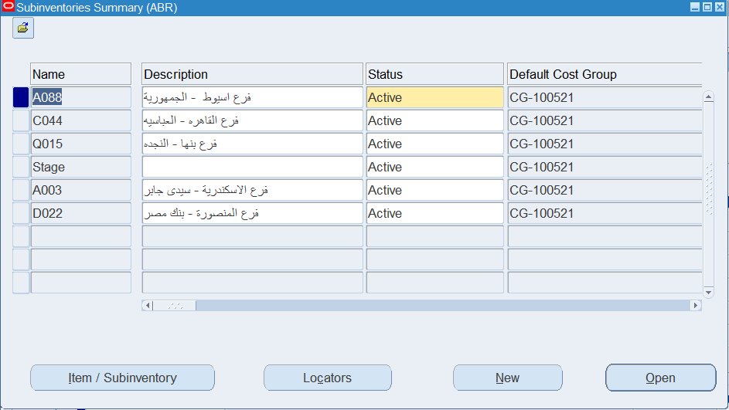

Figure 24 Verify AB Retail_Org and Subinventories

##### ****Conclusion****

By following these steps, you will have successfully created:

* **AB WH_Org** with Subinventories **Cairo WH** and **Upper WH**.
* **AB Retail_Org** with Subinventories **Retail Store 1**, **Retail Store 2**, **Retail Store 3**, **Retail Store 4**, and **Retail Store 5**.

### 4.5 Assign Costing Methods and Calendar

**Step-by-Step Instructions:**

**1. Navigate to Costing Setup:**

* Responsibility: **Inventory or Cost Management**
* Menu: **Setup > Organizations > Parameters**

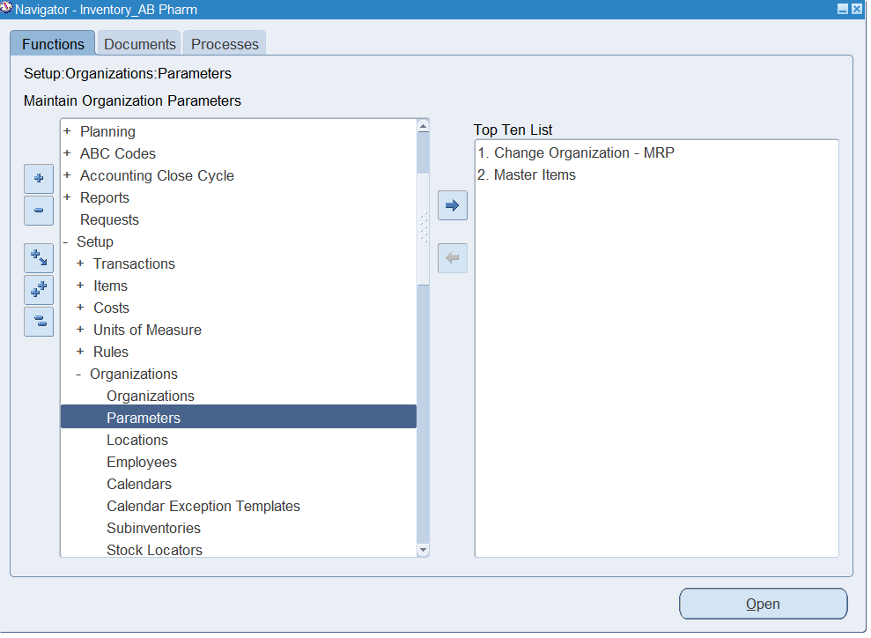

Figure 25 Organization Parameters Screen

**2. Select Your Organization:**

* Choose the Inventory Organization from the list.
* Click **Find**.

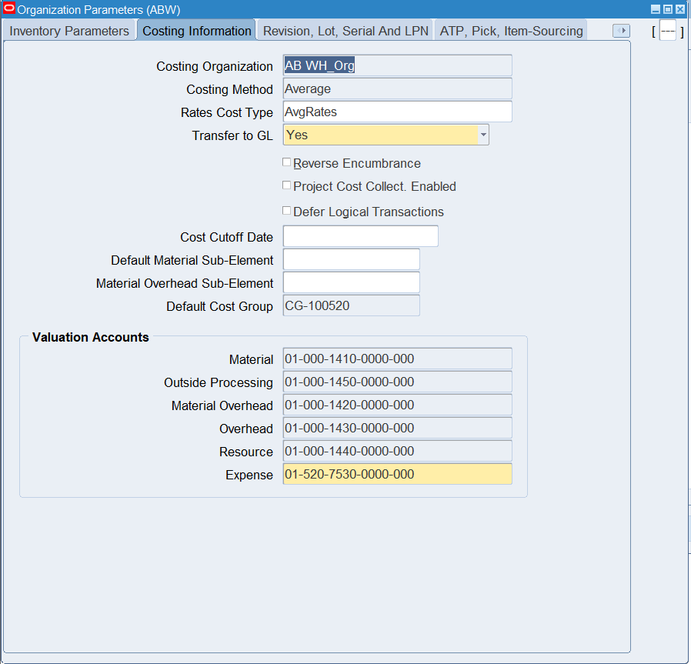

Figure 26 assign Cost center for AB_WH_Org

**3. Assign Costing Method:**

* In the **Costing Information** section:
  + Select the **Costing Method** (e.g., Standard, FIFO, LIFO, Average).
  + Choose **Average** for regulatory tracking and control common in pharma.

**5. Save Parameters:**

* After completing the Costing Method and Calendar fields, save your changes.
* Review and validate all settings.

### 4.6 Configure Inter-Organization Shipping Networks

Configuring Inter-Organization Shipping Networks allows you to define how material is transferred between different inventory organizations, such as warehouses or distribution centers.

**Step-by-Step Instructions:**

**1. Responsibility:** Inventory Super User  
**2. Navigation:**  
Setup > Organizations > Shipping Networks

**3. Create Shipping Network:**

* **From Organization:** Select the source organization (e.g., AB WH_Org)
* **To Organization:** Select the destination organization (e.g., Alexandria Distribution Center)

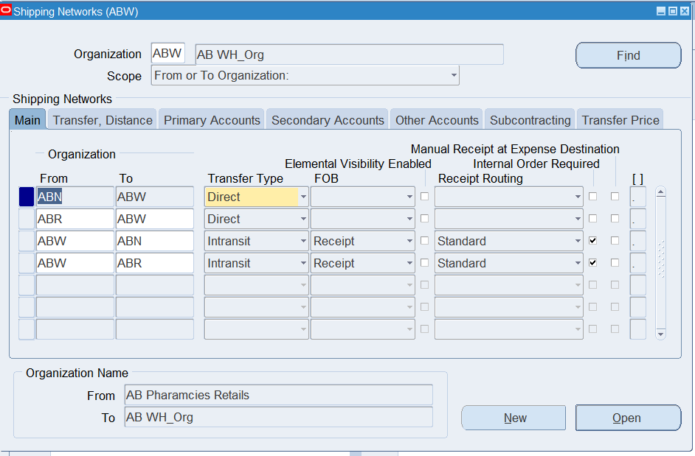

Figure 27 Shipping Network Eatery Screen

**4. Define Transfer Details:**

* **Transfer Type:** Choose one:
  + **Intransit:** Goods are shipped and received separately; typically used when using transportation between sites.
  + **Direct:** Inventory moves immediately without transit delay.
* **FOB (Freight on Board) Point:** Defines the ownership point (e.g., Shipping or Receipt)
* **Shipping Method:** Choose or define a valid method (Truck, Air, etc.)

**4.7 Create Custom Responsibilities and Assign to Users**

Create custom responsibilities for key Oracle SCM modules, adjust profile options, and assign to your user.

**Responsibilities to Create:**

* Custom Order Management
* Custom Receivables Manager
* Custom Oracle Pricing
* Custom Inventory
* Custom Purchasing

**Steps to Create Each Responsibility:**

1. **Responsibility:** System Administrator
2. **Navigation:** Security > Responsibility > Define
3. Enter:
   * **Responsibility Name** (e.g., Inventory_AB Pharm)
   * **Application** (e.g., Inventory)
   * **Responsibility Key**
   * **Menu** (Assign the standard menu, or a custom one if required)
   * **Data Group**: ‘Standard’ or one based on your setup
   * **Request Group**: Match to application (e.g., Inventory All)
4. Save the responsibility

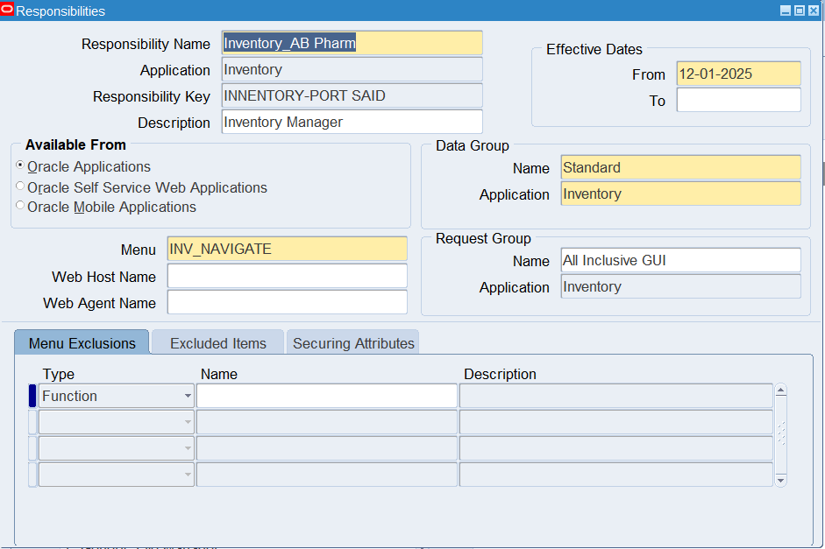

Figure 28 Responsibility Creation Screen

**Profile Options to Set for Each Responsibility:**

1. **MO: Operating Unit** – Set to your operating unit
2. **MO: Security Profile** – Attach relevant HR security profile
3. **GL Ledger Name** – Attach primary ledger
4. **HR: Security Profile** – Ensure employee access
5. **HR: Business Group** – Set business group
6. **MO: Default Operating Unit** – Same as MO: Operating Unit
7. **Responsibility HR Security Profile** – Same as HR: Security Profile

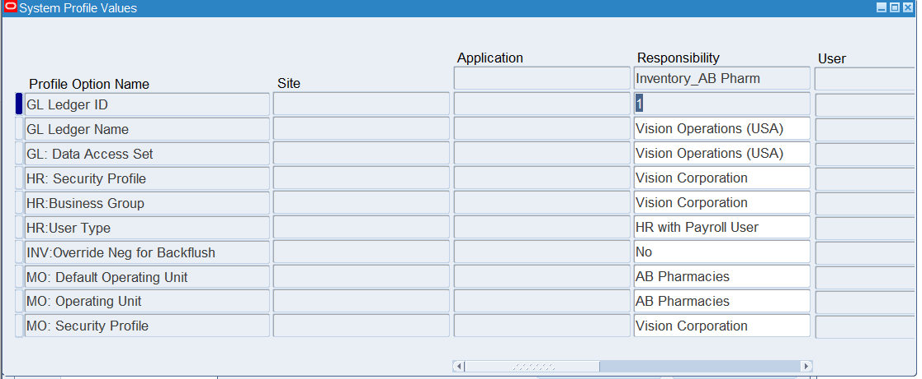

Figure 29 Profile Options Form

**Assign Responsibilities to User:**

1. **Navigation:** Security > User > Define
2. Query your username
3. Add the newly created responsibilities to the user
4. Save changes

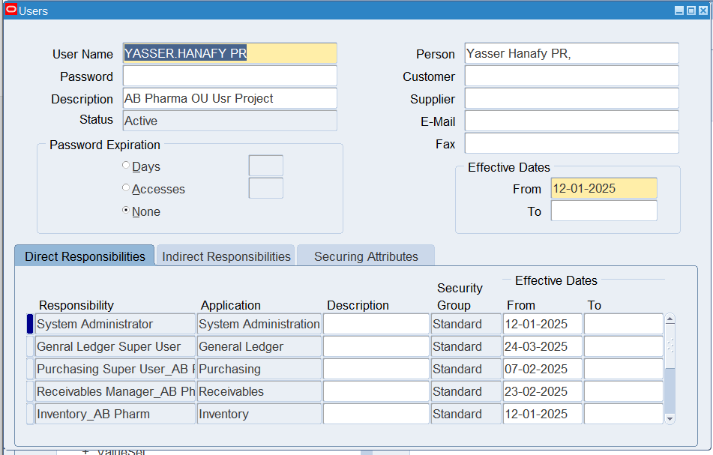

Figure 30 User Form with Assigned Responsibilities

**4.8 Create Master Organization and Inventory Organizations**

**4.8.1 Create Master Organization**

**1. Navigate to Organization Setup:**

* **Responsibility**: **Inventory Super User**
* **Menu**: Setup > Organizations > Organizations

**2. Define Master Organization:**

* **Organization Name**: Enter **AB Pharm_Master** as the name for the master organization.
* **Organization Type**: Select **Master Organization** from the dropdown.
* **Primary Organization**: Assign the organization as a **Primary Organization** for easier tracking of business processes.
* **Description**: Provide a meaningful description of the master organization, such as **Corporate Headquarters** or **Global Operations**.

**3. Assign to Business Group:**

* Under the **Business Group** section, assign the master organization to the appropriate group (if applicable).

**4. Set Legal Entity:**

* Link the master organization to a **Legal Entity** if required (use the one created in **Section 4.3**).

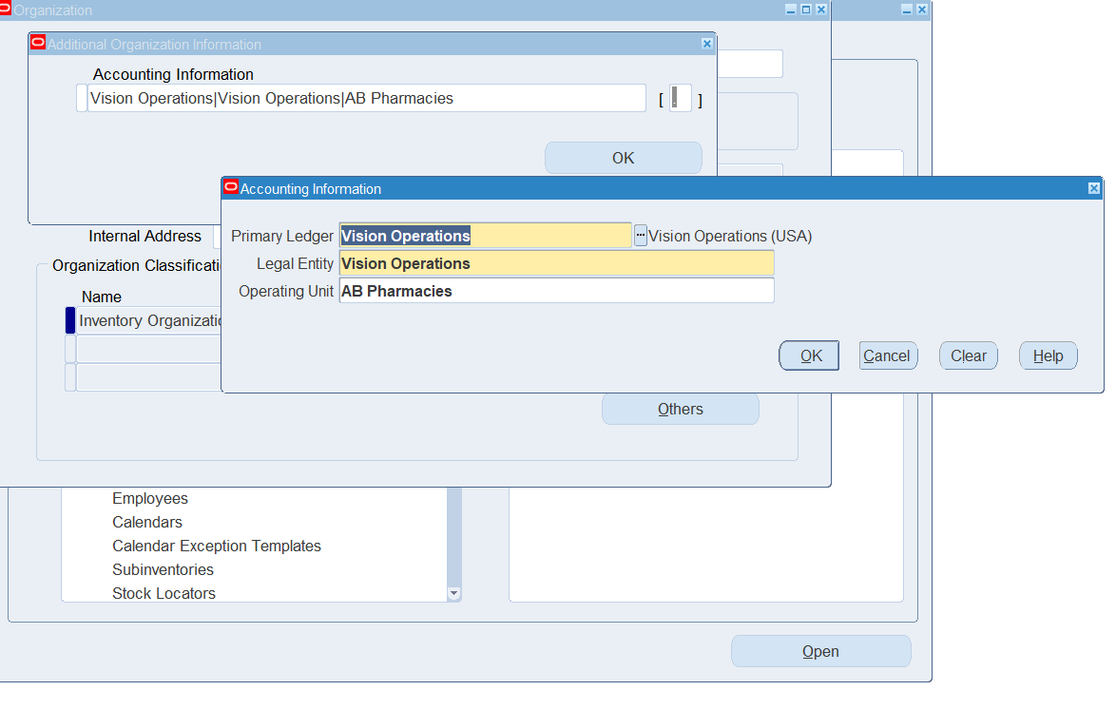**5. Save the Master Organization Setup**

* Click **Save** to store the configuration.

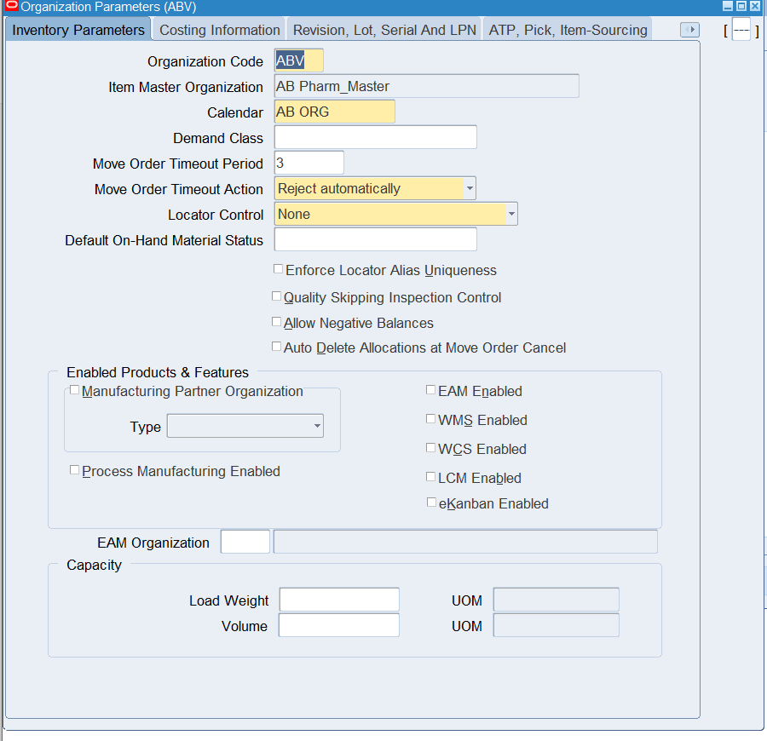

Figure 31 Master Organization Setup Screen

# Purchasing Module Configuration

## Over view

The Oracle Purchasing module allows organizations to automate and manage procurement processes including requisitions, purchase orders, supplier management, and approval workflows.

## ****Step-by-Step Configuration****

### ****Define Financials Options for AB Pharmacies OU****

The **Financials Options** window in Oracle Applications is used to configure shared defaults and settings for **Oracle Payables, Oracle Purchasing, and Oracle Assets**. These options streamline data entry for suppliers, requisitions, purchase orders, invoices, and payments. Changes to defaults only apply to future transactions (e.g., updating **Payment Terms** won’t affect existing suppliers).

* **Define Financial Options**

**Responsibility:** Purchasing  
**Navigation:** Setup > Organizations > Financials options

Oracle Financial Options define default settings and controls for your operating unit’s financial transactions across Purchasing, Payables, Projects, etc.

##### ****Step-by-Step Configuration****

##### ****Step 1: Query Operating Unit****

* Open the Financial Options form
* Select your Operating Unit (e.g., AB WH_Org or AB Retail_Org)

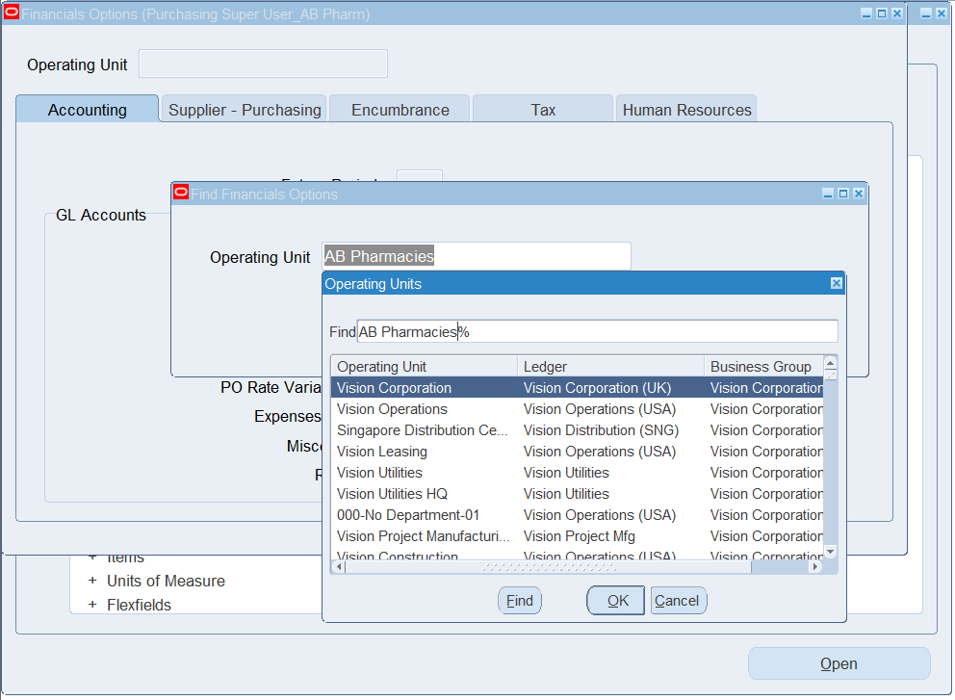

Figure 32 Operating Unit Query Form

##### ****Step 2: Setup options in accounting tap****

To configure foundational financial defaults for AB Pharmacies’ Oracle E-Business Suite (EBS) environment. These settings are critical to ensure proper integration between Oracle Purchasing, Payables, Assets, and Human Resources. They streamline supplier creation, purchase order processing, payment workflows, and expense management.

* Set account period to 2 period
* Fill the GL Panels account as showing in the following screen shot

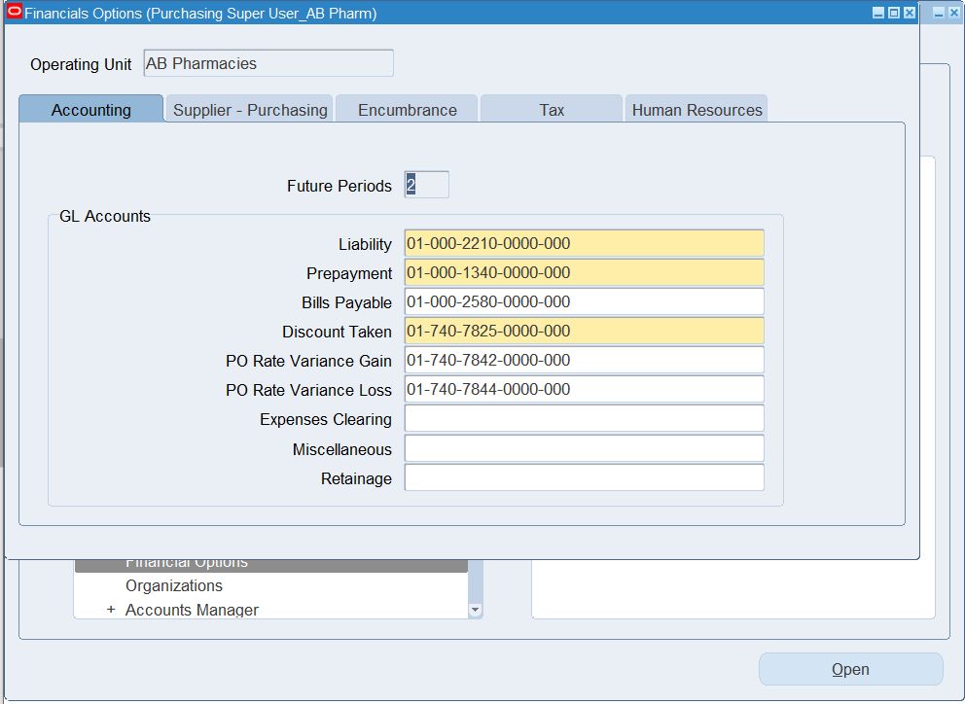

Figure 33 Setup Accounting Informations

📌 Screenshot Placeholder: Accounting Tab

##### ****Step 3:**** Supplier - Purchasing Financials Options

* Click the **Supplier-Purchasing** tab
  + Prepayment
* **RFQ Only Site (Optional)**
  + Checkbox: "RFQ Only Site as Default"
  + If enabled, new suppliers will be RFQ-only by default
  + Prevents PO creation for these suppliers
* **Location Defaults**
  + **Ship-To Location**:
    - Select from LOV or create new in:  
      **HRMS > Work Structures > Location**
  + **Bill-To Location**:
    - Follow same process as Ship-To
* **Shipping & Freight**
  + **Ship Via**:
    - **Select default freight carrier**
    - **Create new carriers in:**  
      **Purchasing > Setup > Freight > Carriers**
* **FOB**:
  + - Choose default (e.g., "Origin", "Destination")
    - Add new terms in:  
      **Purchasing > Setup > Lookups > FOB**
* **Freight Terms**:
  + - Set who pays freight (e.g., "Prepaid", "Collect")
    - Manage in same Lookups window as FOB
* **Inventory Organization.**

You need to choose an inventory organization if you use Purchasing. You can associate each of your Purchasing operating units with one Inventory item master organization. When you associate your Purchasing operating unit with an inventory organization, items you define in this organization become available in Purchasing. You can only choose an inventory organization that uses the same ledger as your Purchasing operating unit.

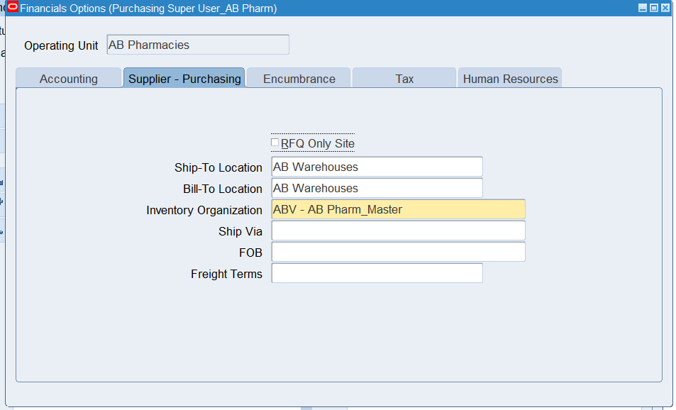

Figure 34 Setup Supplier – Purchasing

##### ****Step 4: HR and Other Settings****

* Attach the default HR Organization
* Choose default employee numbering methods
* Assign Invoice Approval Routing options

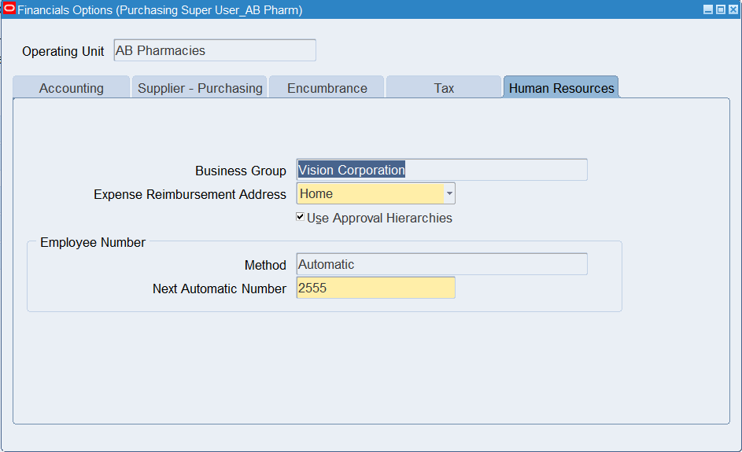

Figure 35 Setup HR Tab and Other Options

##### ****Step 6: Save & Validate****

* Click Save to confirm setup
* Validate the fields for completeness

#### 5.1 Define Purchasing Options

**1. Navigate to the Purchasing Setup:**

* **Responsibility**: **Purchasing Super User**
* **Menu**: Setup > Purchasing > Purchasing Options

**2. Configure General Options:**

* **Purchasing Document Type**: Define the types of purchase documents used by your company (e.g., Standard Purchase Order, Blanket Purchase Agreement, etc.)
* **Document Approval**: Enable or disable document approval workflows.
* **Supplier Site Assignment**: Ensure that suppliers are associated with a site for efficient processing.
* **Receipt Routing**: Set default routing for receiving goods (e.g., Direct Delivery, Inspection Required, etc.)
* **Shipment Terms**: Define the commonly used shipment terms like FOB (Free on Board).

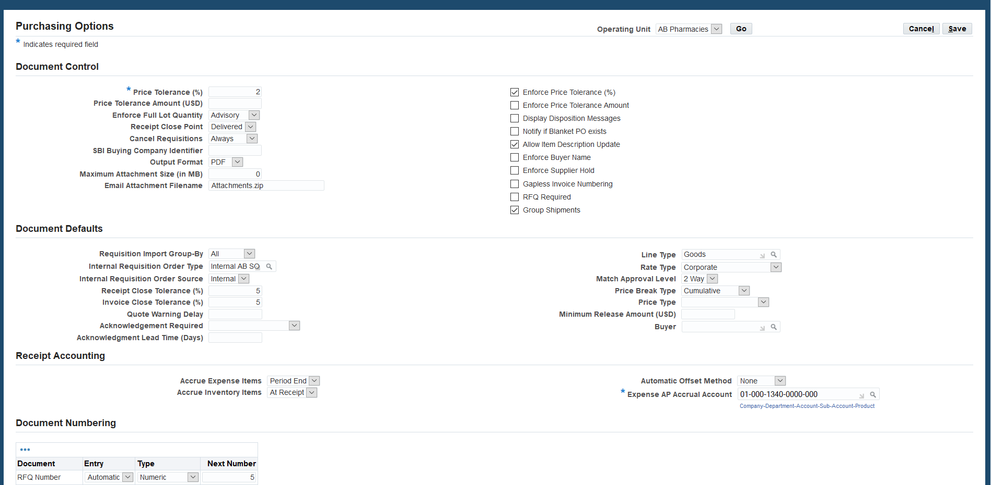

Figure 36 Purchasing Options Setup Screen

**3. Set Buyer Options:**

* **Buyer Name**: Set up individual buyers or assign buyers by category (e.g., raw materials, finished goods).
* **Approval Hierarchy**: Set the buyer approval hierarchy to ensure compliance with the company’s approval process.

### ****Step-by-Step: Buyer Setup in Oracle Purchasing****

**Responsibility:** Purchasing Super User  
**Navigation Path:** Purchasing > Setup > Personnel > Buyers

#### ****Step 1: Define Buyer****

1. Navigate to the **Buyers** form.
2. Click **New** to create a new buyer record.
3. **Enter the Employee Name**:
   * This must be an employee already defined in Oracle HRMS.
   * Example: Ahmed Bhaa (Procurement Officer).
4. Assign a **Buyer Name** (automatically populated from the employee).
5. Select the **Start Date** (usually today's date).
6. **End Date** can be left blank unless the buyer is temporary.
7. Save the record.

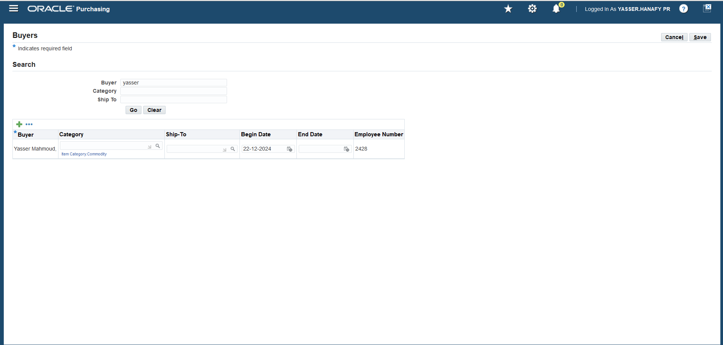

Figure 37 Define Buyer

#### ****Step 2: Assign Buyer to Operating Unit****

1. Confirm the buyer is assigned to the correct **Operating Unit**:
   * Example: AB Pharmacies OU.
2. This allows the buyer to create Purchase Orders and Requisitions only for the selected OU.

#### ****Step 3: Grant Buyer Access (Optional)****

1. If using **Approval Hierarchies**:
   * Make sure the buyer is included in the appropriate **Position Hierarchy**.
   * 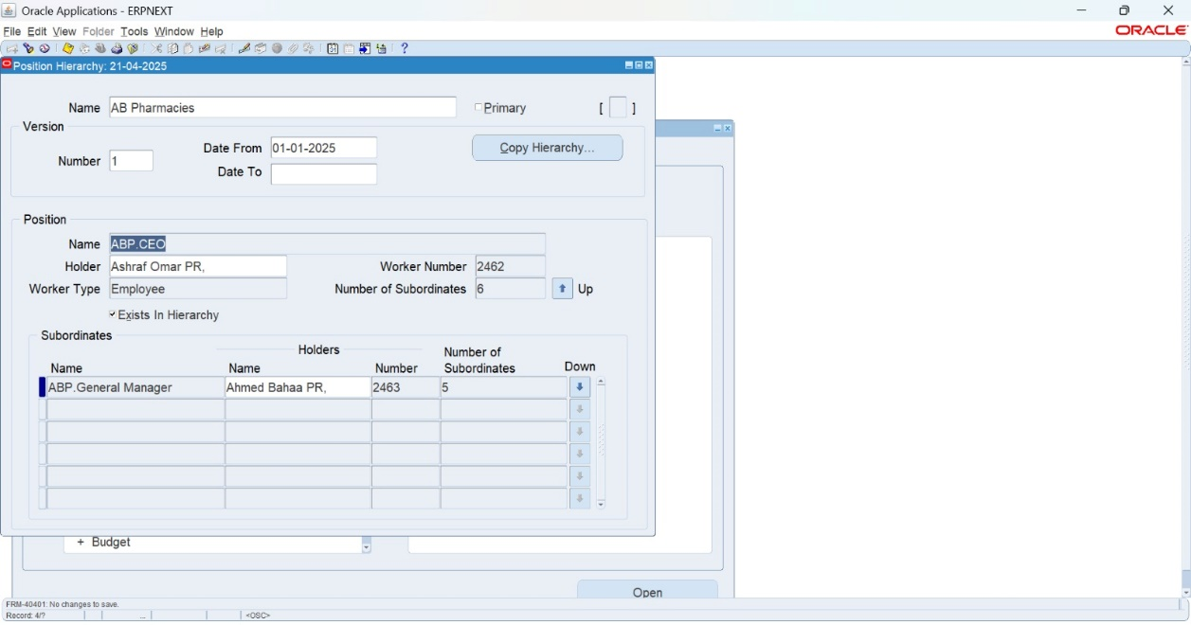Navigate to: HRMS > Work Structures > Position > Position Hierarchy.

Figure 38 Grant Buyer Access

1. Link the employee’s position (e.g., Senior Buyer, Procurement Manager) to the hierarchy used in purchasing approvals.

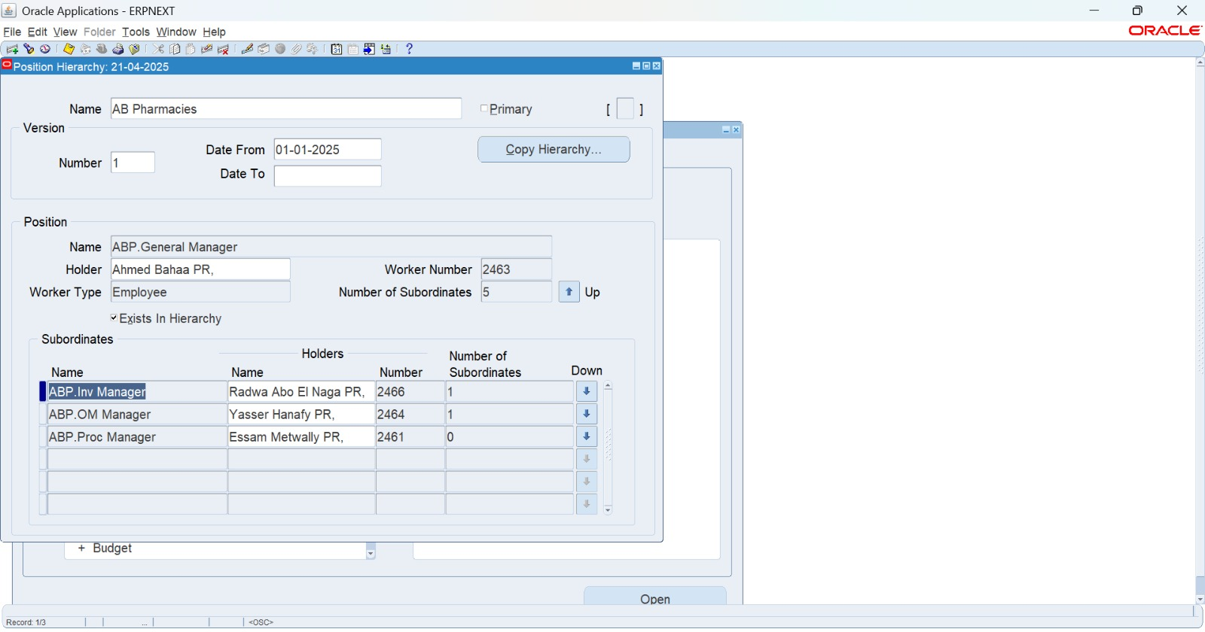

Figure 39 setup Positions Hierarchy

#### ****Step 4: Link Buyer to User Account****

1. Navigate to: System Administrator > Security > User > Define.
2. Query the user account for the buyer (e.g., AEL_SCM_BUYER).
3. In the **Person** field, link the user to the corresponding **HR Employee Record**.
4. Assign the responsibility: Purchasing Super User or Buyer Work Center.

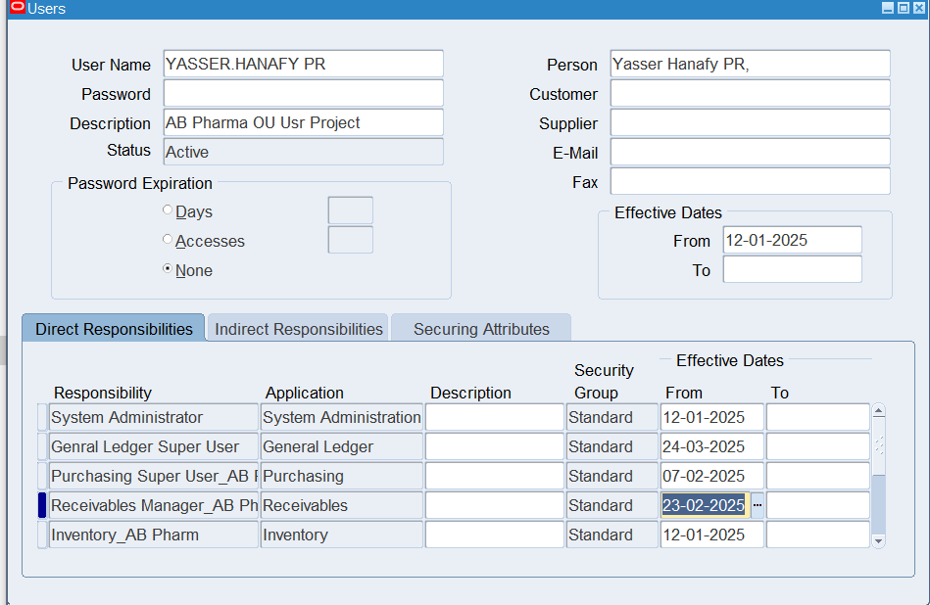

Figure 40 Link Buyer to user Account

#### ****Step 5: Test Buyer Assignment****

1. Log in using the buyer’s credentials.
2. Navigate to: Purchasing > Purchase Orders > Purchase Orders.
3. Try creating a new PO.
   * The **Buyer field** should auto-populate.
   * The user should be able to enter vendors, items, and submit for approval.

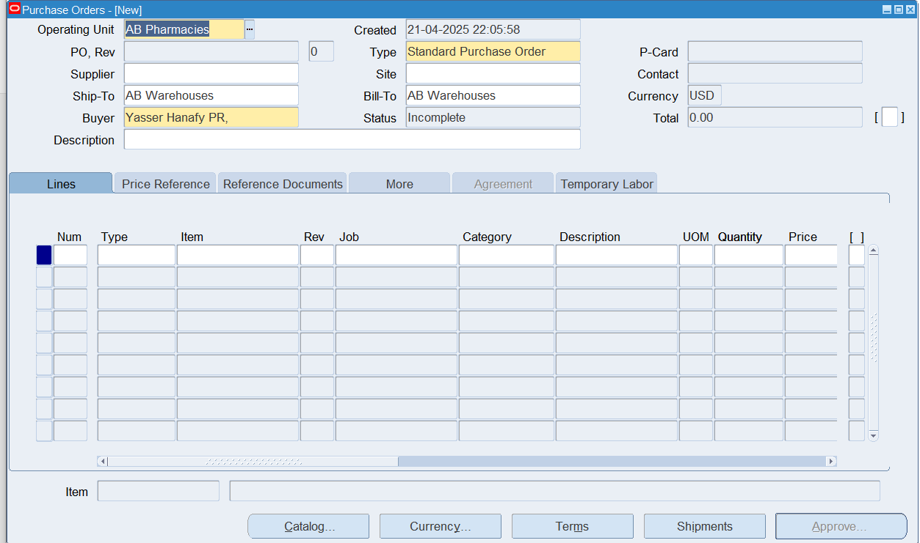

Figure 41 Create Requisition

**5.2 Define Suppliers and Supplier Sites**

**1. Navigate to Supplier Setup:**

* **Responsibility**: **Purchasing Super User**
* **Menu**: Suppliers > Suppliers

**2. Create Supplier:**

* **Supplier Name**: Enter the supplier name (e.g., Pharma Supplier A)
* **Supplier Type**: Select the appropriate type (e.g., Manufacturer, Distributor, etc.)
* **Supplier Status**: Mark as "Active" or "Inactive" depending on the status of the supplier.

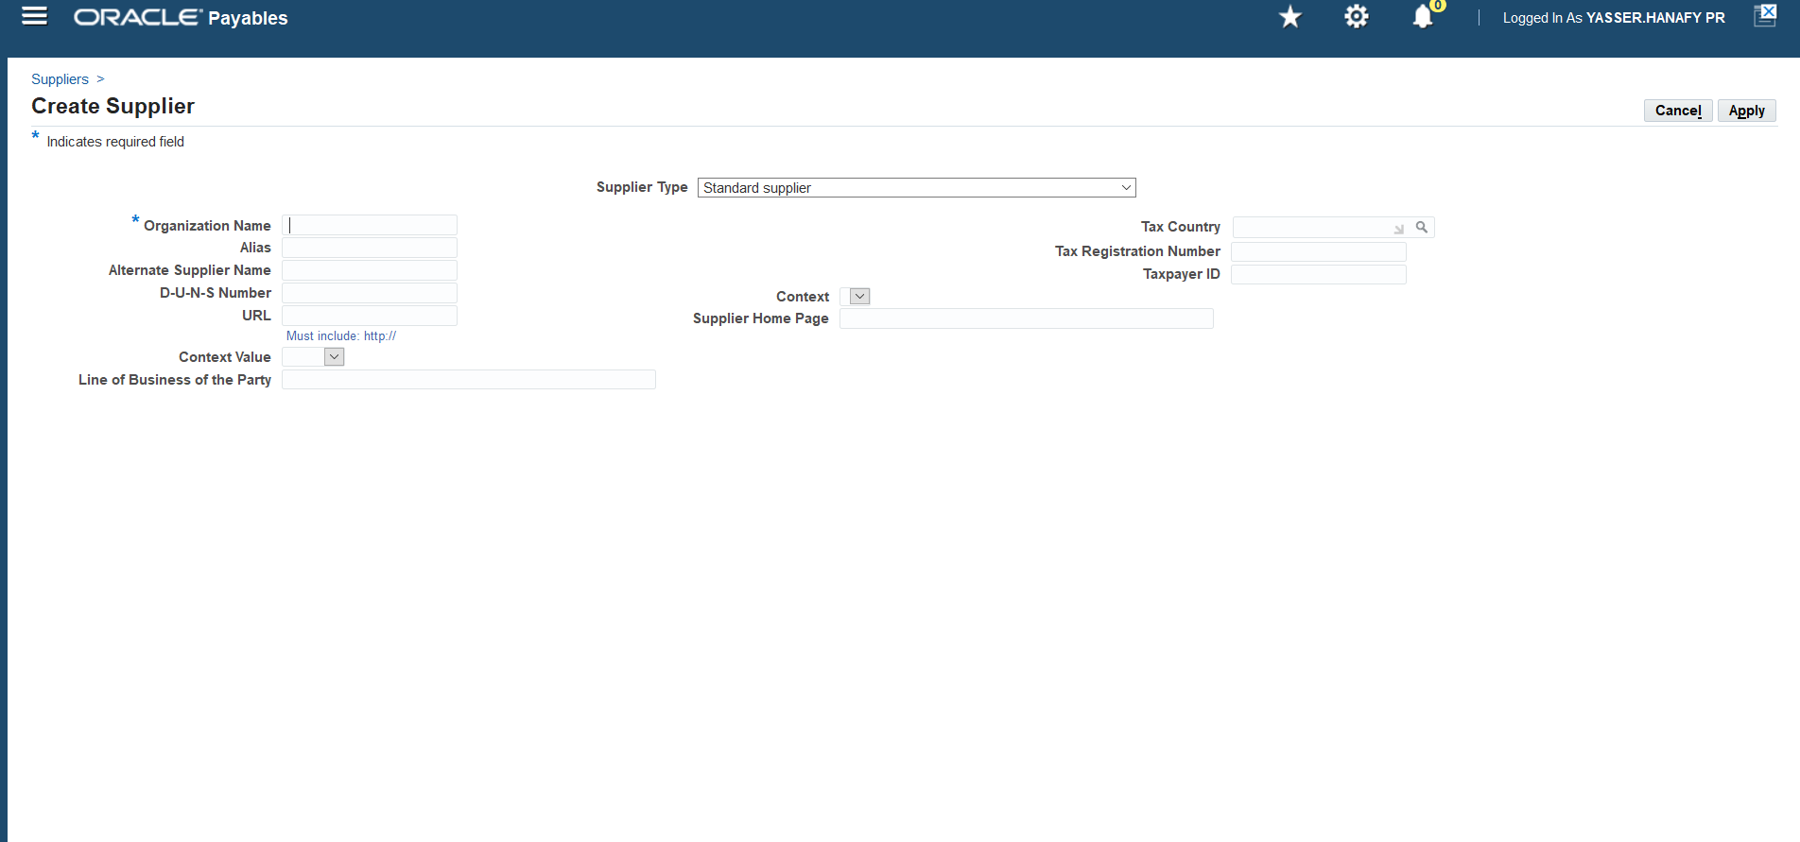

Figure 42 Define Suppliers and Supplier Sites

**3. Define Supplier Site:**

* **Site Name**: Define the location where goods will be shipped (e.g., Supplier A Warehouse).
* **Site Code**: Unique identifier for the site.
* **Address**: Fill in the full address (street, city, country, etc.)
* **Default Payment Terms**: Set the default payment terms for the supplier.

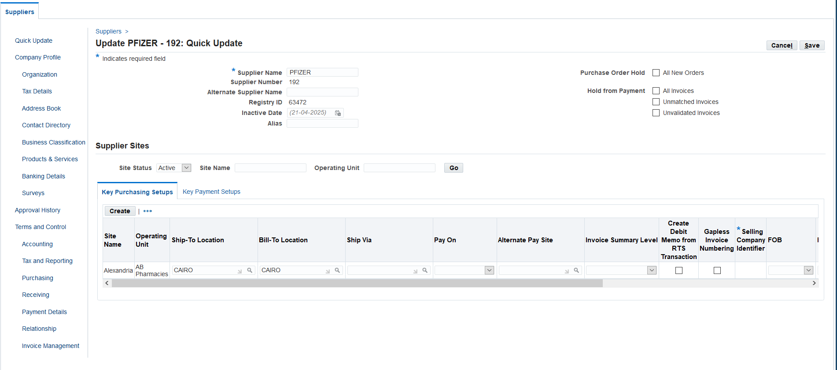

Figure 43 Supplier Setup Screen

**4. Assign Supplier to Purchasing Organization:**

* Make sure suppliers are correctly mapped to your Purchasing Organization to streamline order management.

**5. Set Up Purchase Order Types**

**1. Navigate to Document Types Setup:**

* **Responsibility**: **Purchasing Super User**
* **Menu**: Setup > Purchasing > Document Types

**2. Define Purchase Order Types:**

* **Standard Purchase Order**: Set this as the default document type for regular procurement transactions.
* **Blanket Purchase Agreements**: Configure if used to make long-term agreements with suppliers.
* **Contract Purchase Agreements**: Set up if your company works with contracts for negotiated terms.

**3. Set Approval Methods:**

* 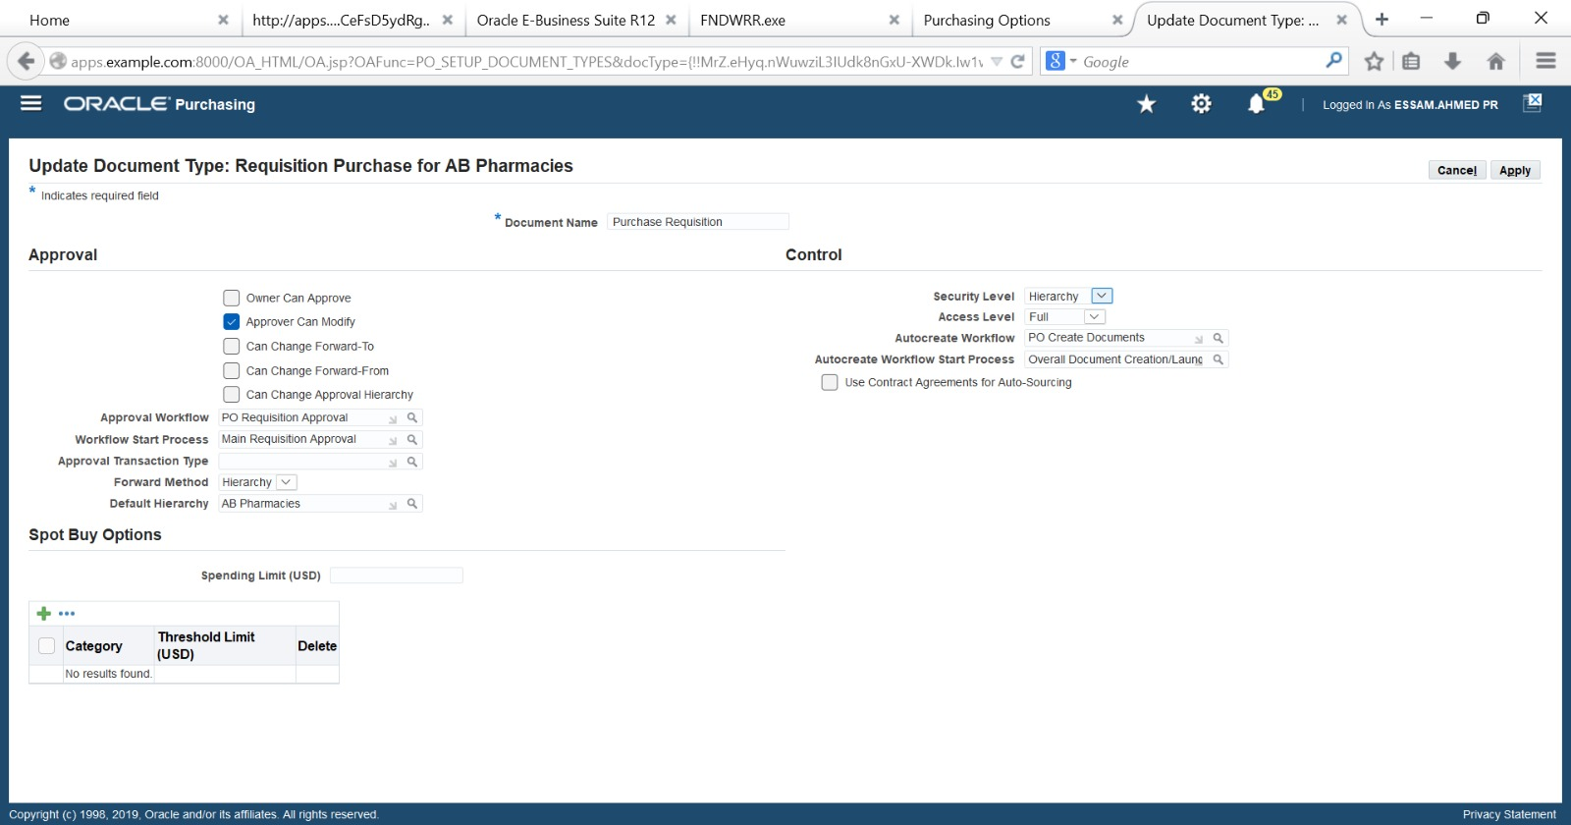Configure whether purchase orders need approval before they can be processed or whether they can be automatically approved.

Figure 44 Setup Apporvoal Method

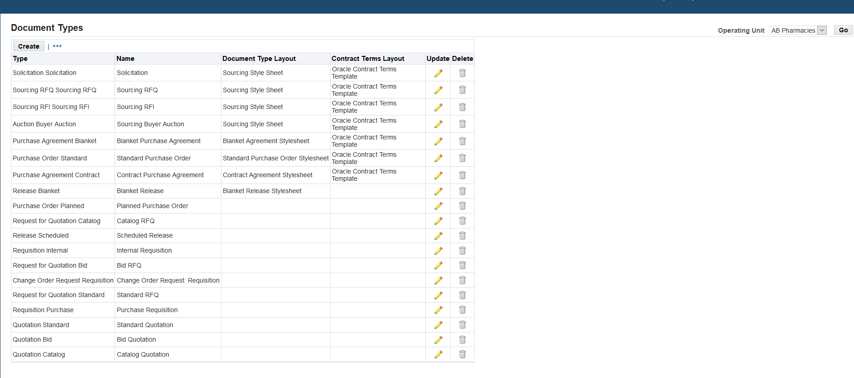

Figure 45 Purchase Order Document Types Setup Screen

## 3. ****Creating an Approval Group in Oracle Purchasing****

**Responsibility:** Purchasing Super User  
**Navigation Path:**  
Purchasing > Setup > Approvals > Approval Groups

### ****Step 1: Open the Approval Groups Form****

1. Navigate to: Purchasing > Setup > Approvals > Approval Groups
2. The **Approval Groups** window will open.

### ****Step 2: Create a New Approval Group****

1. In the **Name** field, enter the group name  
   → Example: Retail PO Approval Group
2. In the **Type** field, choose from:
   * **Document Total:** Based on total PO/requisition value
   * **Account Range:** Based on account range limits

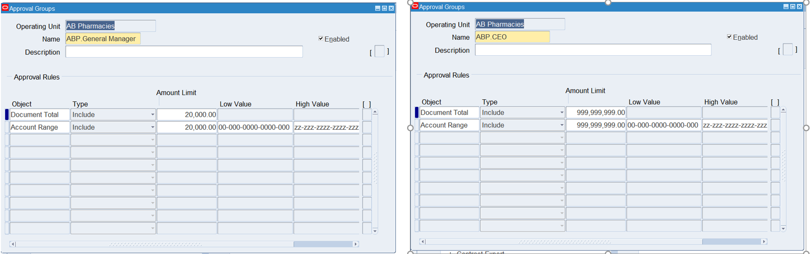

Figure 46 Create approval group

### ****Step 3: Define Approval Limits****

Depending on the type selected:

#### ➤ ****If Type = Document Total:****

1. Enter the **Currency** (e.g., EGP or USD).
2. Set the **Minimum Amount** and **Maximum Amount**.
   * Example: Min = 0, Max = 50,000
3. Optionally, enter a **Charge Account** or leave it open for all accounts.

#### ➤ ****If Type = Account Range:****

1. Enter the account range in **From** and **To** fields.
2. Enter min/max approval amounts for each account segment.

### ****Step 4: Assign the Approval Group to Position or Job****

Approval groups are linked to positions/jobs in HR setups or via Approval Assignments.

* Navigate to: Purchasing > Setup > Approvals > Assign Approval Groups
* Choose the **Job** or **Position**.
* Assign the Approval Group you just created.

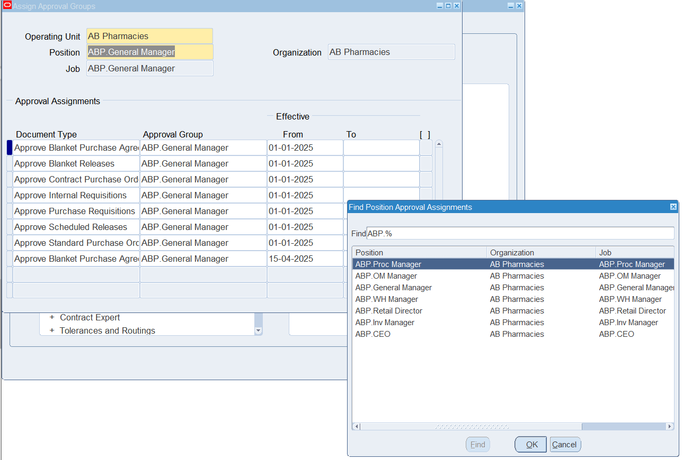

Figure 47 Assign the Approval Group to Position

### ✅ ****Result:****

The Approval Group is now active and can be used in your approval hierarchy. When requisitions or POs are raised, the system checks this group to verify if the approver has authority based on the value or category.

## ****Configure Min-Max Planning with Internal Replenishment****

**Responsibility:** Inventory or Supply Chain Planner  
**Navigation:**  
Inventory > Planning > Min-Max Planning Report  
Inventory > Items > Organization Items  
Inventory > Setup > Sourcing Rules

#### ****Step 1: Enable Min-Max Planning for the Item****

1. Navigate to: Inventory > Items > Organization Items
2. Query the item (e.g., Paracetamol 500mg Tab).
3. Go to the **General Planning** tab:
   * **Inventory Planning Method** = Min-Max
4. Set **Min-Max values** in the **Min-Max Planning** tab:
   * **Minimum Quantity:** 100
   * **Maximum Quantity:** 500
   * **Order Quantity Type:** Fixed or Maximum
5. 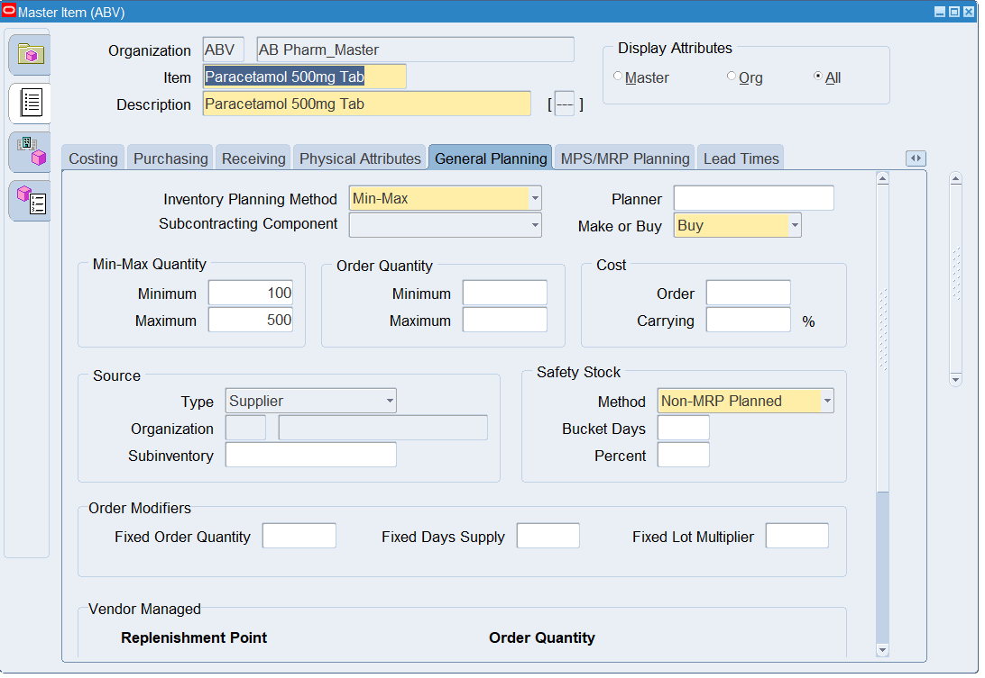Save.

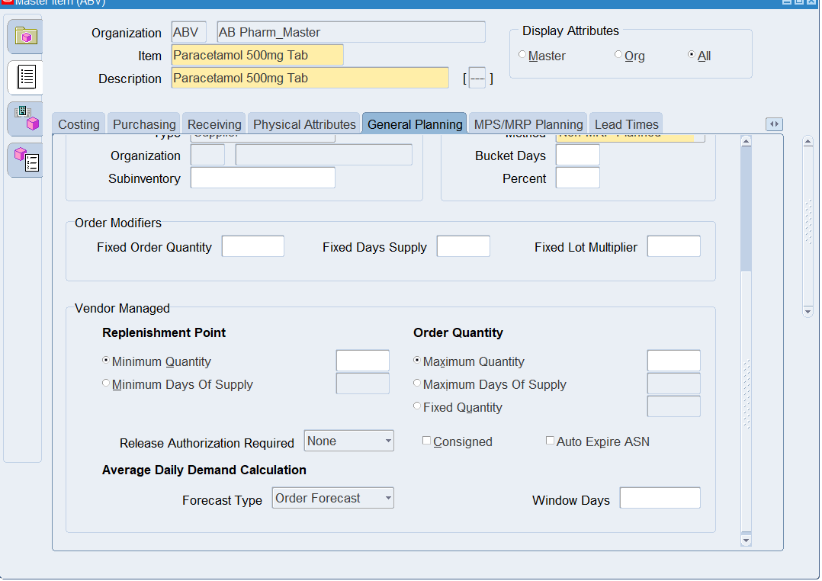

Figure 48 Enable Min-Max Planning for the Item

#### ****Step 2: Set Item Attributes in Receiving Org (Retail Org)****

1. Confirm the item exists in the **destination org** (e.g., Retail WH1).
2. Navigate to the **General Planning** tab:
   * Inventory Planning Method = Min-Max
3. Go to the **Order Management tab** and ensure:
   * **Internal Order Enabled** = ✔️ (Checked)
4. Save.

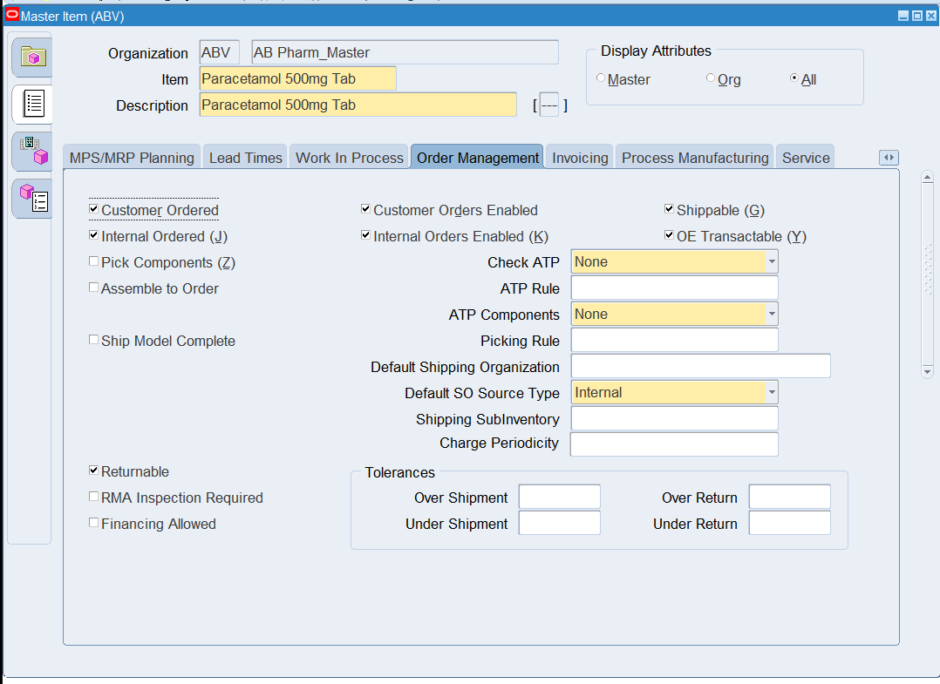

Figure 49 Set Item Attributes in Receiving Org (Retail Org)

#### ****Step 3: Define Sourcing Rule****

1. Navigate to: Purchasing > Supply Base > Sourcing Rules
2. Create a new Sourcing Rule:
   * **Name:** INT_SR_WH1
   * **Assignment Set:** Default or custom (e.g., AB_Sourcing)
   * **From Organization:** AB WH_Org
   * **To Organization:** Retail WH1
   * **Source Type:** Inventory
   * **Source Organization:** AB WH_Org
   * **Allocation %:** 100
3. Save and approve the sourcing rule.

#### ****Step 4: Assign the Sourcing Rule****

1. Navigate to: Inventory > Setup > Rules > Assignment Sets
2. Query or create an assignment set (e.g., AB_Sourcing)
3. Assign the sourcing rule to:
   * **Item**: Or entire category/all items
   * **Organization**: Retail WH1
4. Save.

#### ****Step 5: Run Min-Max Planning Report****

1. Navigate to: Inventory > Planning > Min-Max Planning Report
2. Parameters:
   * **Organization:** Retail WH1
   * **Replenishment Source Type:** Internal
   * **Item:** Optional (leave blank for all)
   * **Create Requisitions:** Yes
   * **Restock:** Yes
3. Submit the request.

#### ****Step 6: Auto-create Internal Requisition****

* Navigate to: Purchasing > Requisitions > Requisition Summary
* Check status: Internal Requisition should be created for the shortfall quantity.
* This requisition will be fulfilled by a Sales Order from the source org (AB WH_Org).

#### ****Step 7: Convert Requisition to Internal Order****

1. Navigate to: Order Management > Order Organizer
2. Run Order Import if needed (from internal req).
3. Fulfill internal sales order from warehouse.

✅ **Result:** Retail WH1 is automatically restocked via internal transfer from AB WH_Org based on Min-Max planning thresholds.

### ****Configure Min-Max Planning at Subinventory Level (Retail)****

**Responsibility:** Inventory Super User  
**Navigation:** Inventory > Planning > Min-Max Planning Report

#### ****Objective:****

To automate replenishment of fast-moving retail inventory items by running Min-Max planning at the subinventory level. This allows AB Pharmacies to maintain optimal stock levels at retail outlets based on real-time demand.

#### ****Step-by-Step Configuration:****

1. **Define Subinventory Parameters (Retail Org)**
   * Navigate to: Inventory > Setup > Organizations > Subinventories
   * Query AB Retail_Org
   * Open subinventory (e.g., **Retail WH3**)
   * Ensure **Inventory Organization** and **locator control** are correctly set.
   * Check “Allow Requisition” box (needed for internal requisitions).
   * Save.
2. **Set Min-Max Planning Parameters at Item-Subinventory Level**
   * Navigate to: Inventory > Items > Master Items
   * Query item (e.g., **Paracetamol 500mg Tab**)
   * Go to **Inventory Org**: AB Retail_Org
   * In **Inventory > Subinventory Planning** tab:
     + **Subinventory:** Retail WH3
     + **Min Quantity:** 100
     + **Max Quantity:** 500
     + **Source Type:** **Inventory** (for internal transfer)
     + **Source Organization:** AB WH_Org (main warehouse)
     + **Source Subinventory:** Cairo WH
     + Save

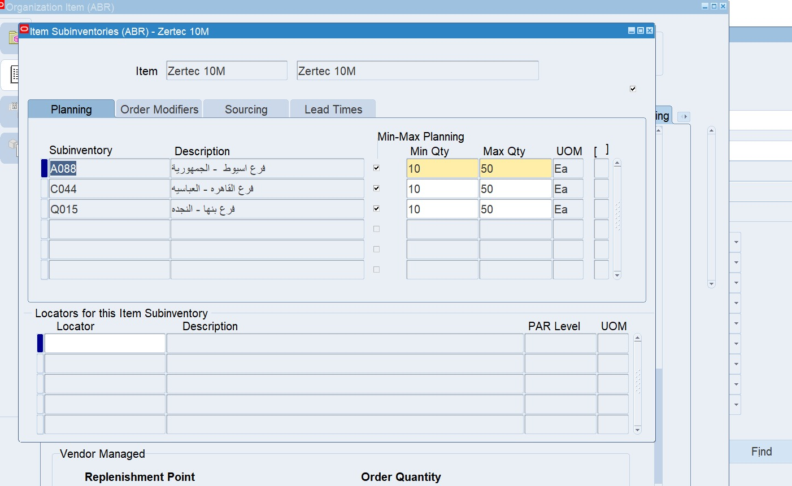

Figure 50 Set Min-Max Planning Parameters at Item-Subinventory Level

1. **Run Min-Max Planning Report**
   * Navigate to: Inventory > Planning > Min-Max Planning Report
   * **Organization:** AB Retail_Org
   * Parameters:
     + **Planning Level:** Subinventory
     + **Subinventory:** Retail WH3
     + **Item/Item Category:** Leave blank to run for all
     + **Source Type:** Inventory
     + **Rest are defaults**
   * Submit the request

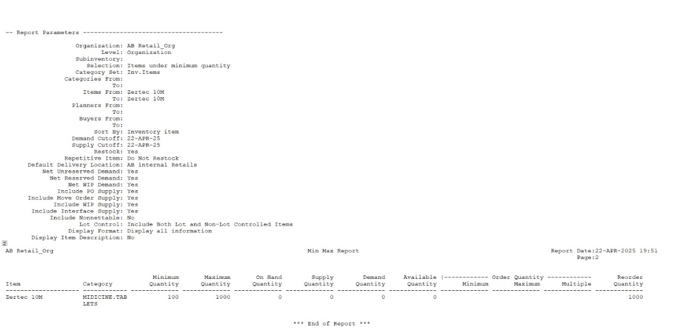

Figure 51 Min-Max Planning Report

1. **Review Results**
   * Navigate to: Purchasing > Requisitions > Requisition Summary
   * Query internal requisitions generated
   * Check source as AB WH_Org and destination as AB Retail_Org > Retail WH3

✅ **Outcome:** Internal requisitions will be auto-created for items below Min level, pulling stock from the main warehouse to the retail outlet.

📌 Tip: Schedule this Min-Max Report periodically (e.g., every morning) using Oracle Concurrent Manager.

# **Conclusion**

The successful implementation of Oracle SCM at **AB Pharmacies** marks a significant milestone in modernizing the company's supply chain operations. The project has delivered tangible improvements across all business functions, including procurement, inventory management, warehouse operations, and order fulfillment.

Following the implementation:

* **Inventory visibility** has improved dramatically, allowing real-time tracking of stock levels, batch numbers, and expiry dates.
* **Procurement cycles** have become faster and more accurate, supported by automated workflows and approval hierarchies.
* **Warehouse operations** are now optimized through locator-controlled storage and systematic put away and picking rules, increasing inventory accuracy and operational efficiency.
* **Financial controls** are tighter, with seamless integration between supply chain transactions and financial modules.
* **Regulatory compliance** is strengthened, with better documentation and audit-ready reports, ensuring adherence to pharmaceutical industry standards.
* **Decision-making** has become more data-driven, with the availability of intelligent dashboards and analytics for forecasting and planning.

The project has not only streamlined day-to-day operations but has also positioned AB Pharmacies to scale efficiently, adapt quickly to market changes, and maintain a competitive edge in the pharmaceutical distribution industry.

This implementation demonstrates the value of strategic technology adoption, strong leadership, and collaborative teamwork in driving digital transformation initiatives to successful outcomes.

# **References**

1. **Oracle Corporation.**  
   Oracle E-Business Suite Supply Chain Management User Guides  
   Retrieved from [Oracle Documentation Library](https://docs.oracle.com/en/applications/)
2. **Digital Egypt Pioneers Initiative (DEPI).**  
   Training Program: Oracle ERP and Supply Chain Management Fundamentals  
   Ministry of Communications and Information Technology (MCIT), Egypt.
3. **Ahmed Bakar, Senior Instructor.**  
   Training Sessions and Practical Workshops on Oracle SCM Applications  
   Conducted under DEPI Training Program, 2025.
4. **Best Practices in Pharmaceutical Supply Chain Management.**  
   World Health Organization (WHO) Technical Reports.  
   Retrieved from [WHO Publications](https://www.who.int/publications)
5. **Internal Business Requirements Documents.**  
   AB Pharmacies SCM Requirements Specification, 2025.
6. **Internal System Configuration Guides.**  
   Oracle SCM Configuration Documentation developed for AB Pharmacies project team.